What is Selenium?

* Selenium is a suite of tools for automating web browsers.

**How to Create a Maven Project in Eclipse?**

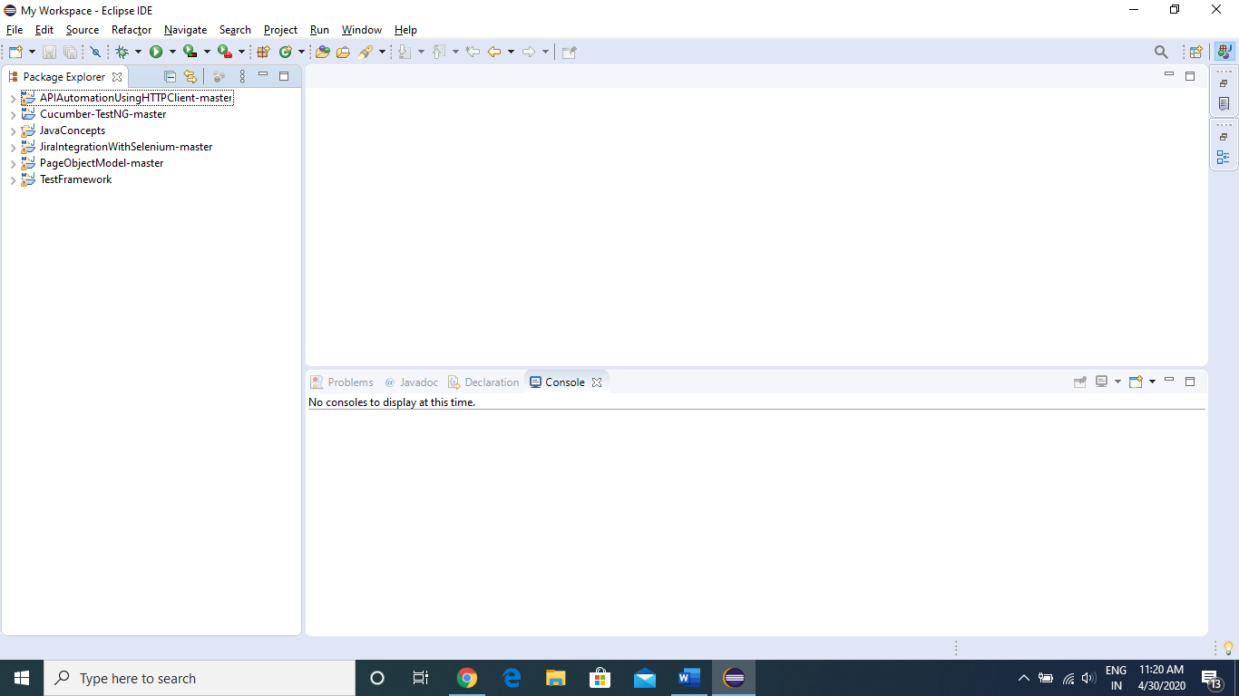

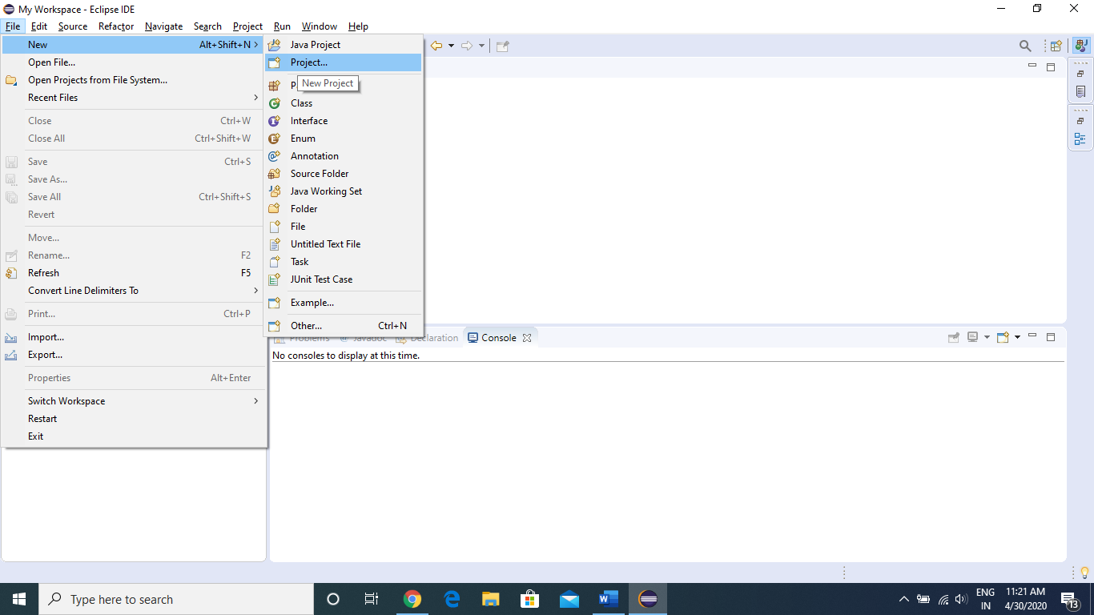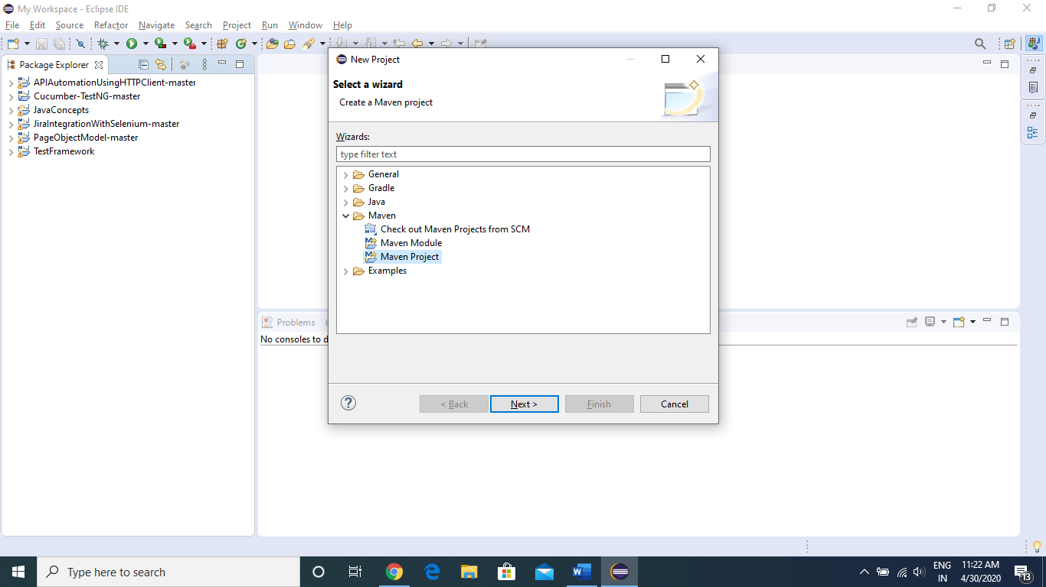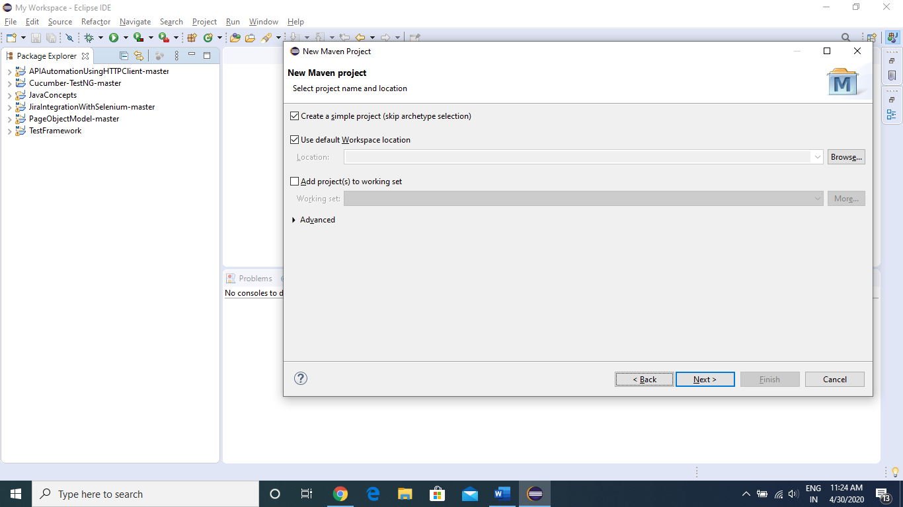

**Enter Group ID and Artifact ID in below format.**

groupId

* com.companyname.project

artifactId

* project

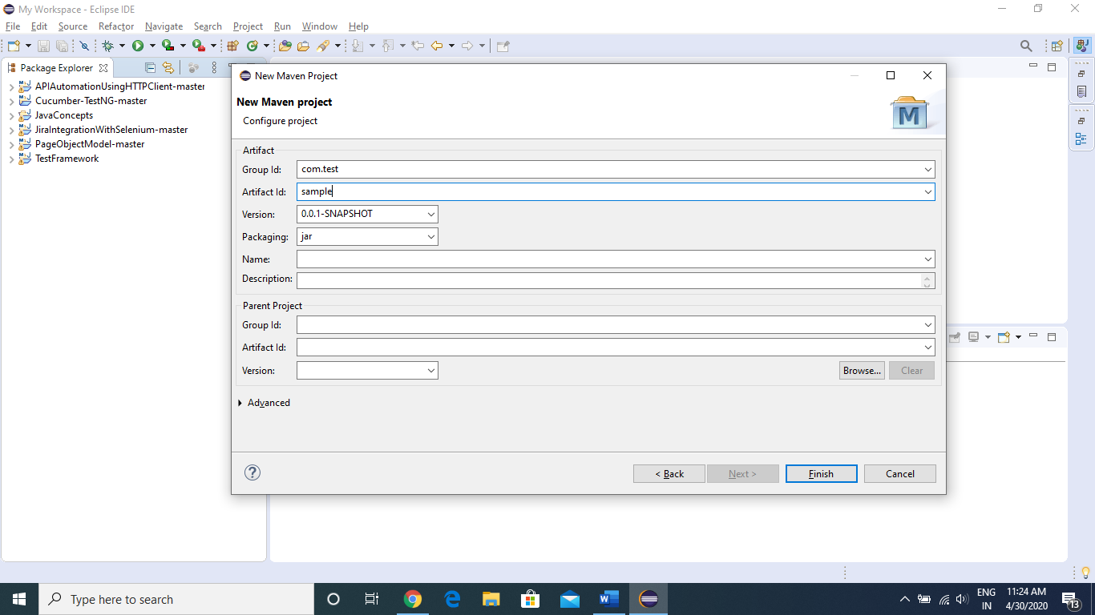

Now as you can see in below image, our **Sample maven project** is ready

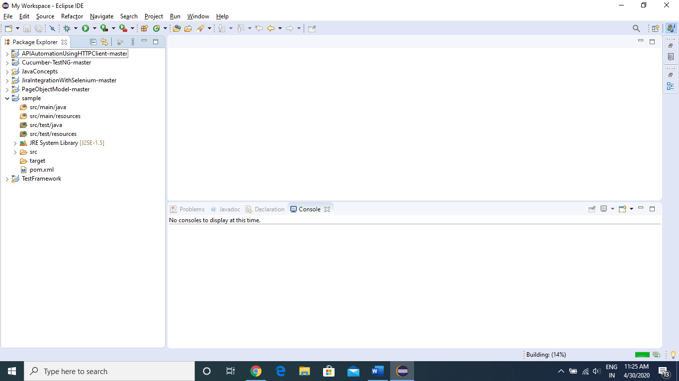

Now we will see how to add dependencies in our project.

Dependencies are the JAR files we need in our project, so as we are working on Selenium, we require Selenium jar file.

To get Selenium Jar dependency, we will go to below website.

<https://mvnrepository.com/>

Search for “Selenium JAVA” in the above website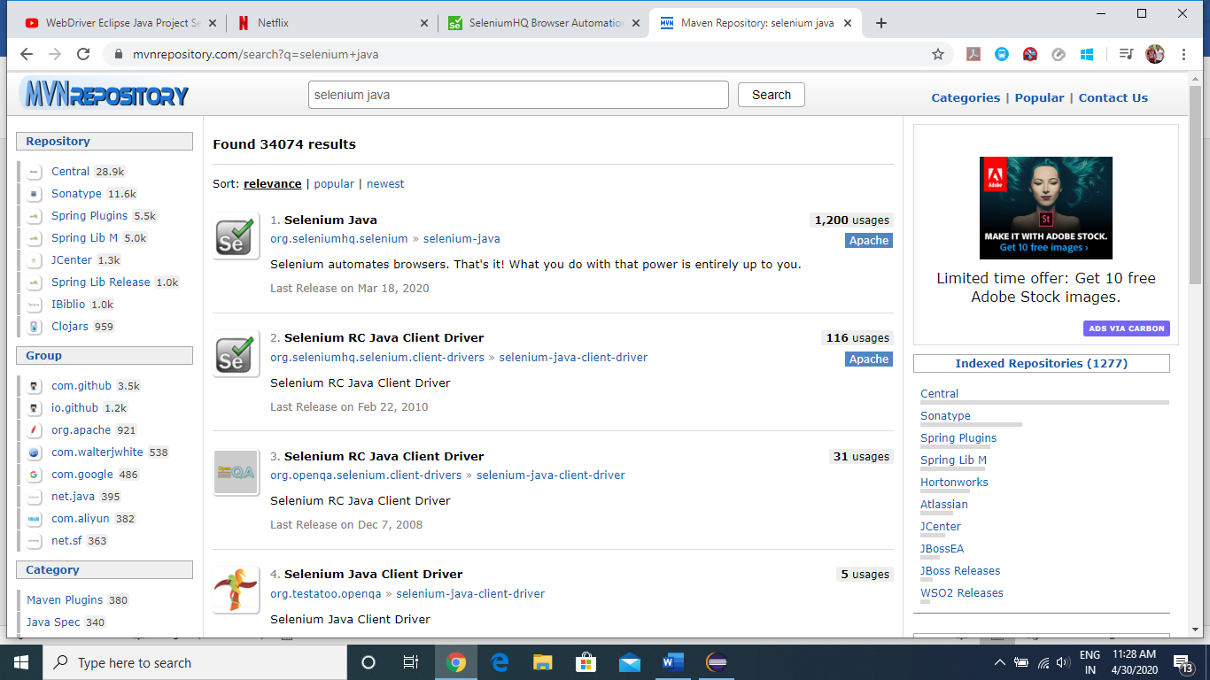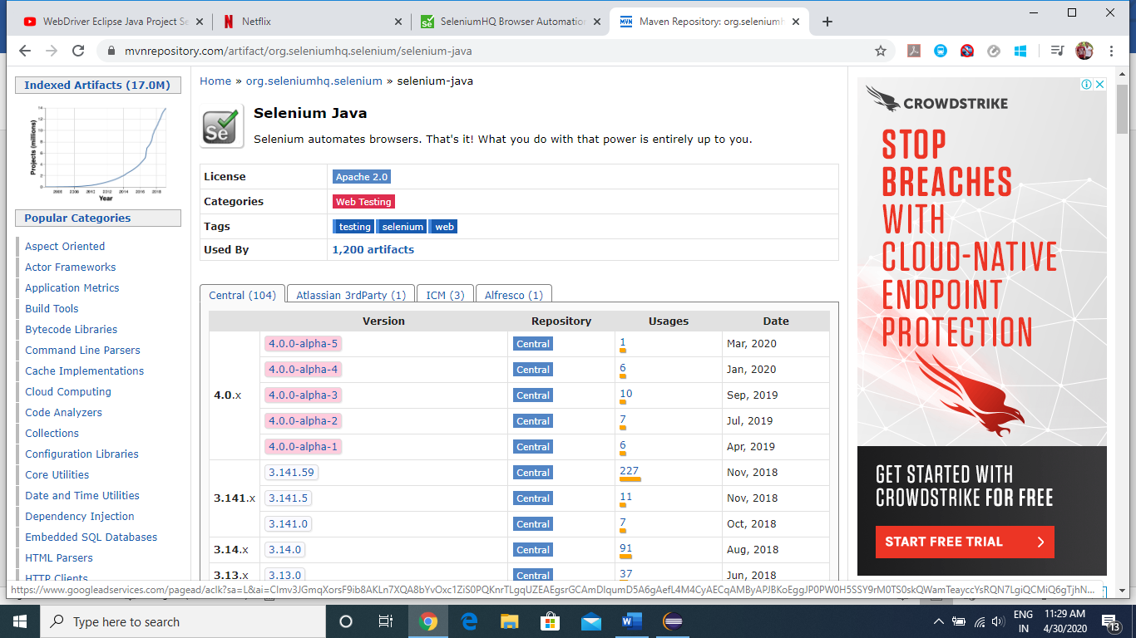

We will be using the stable version of selenium, which is **3.141.59**

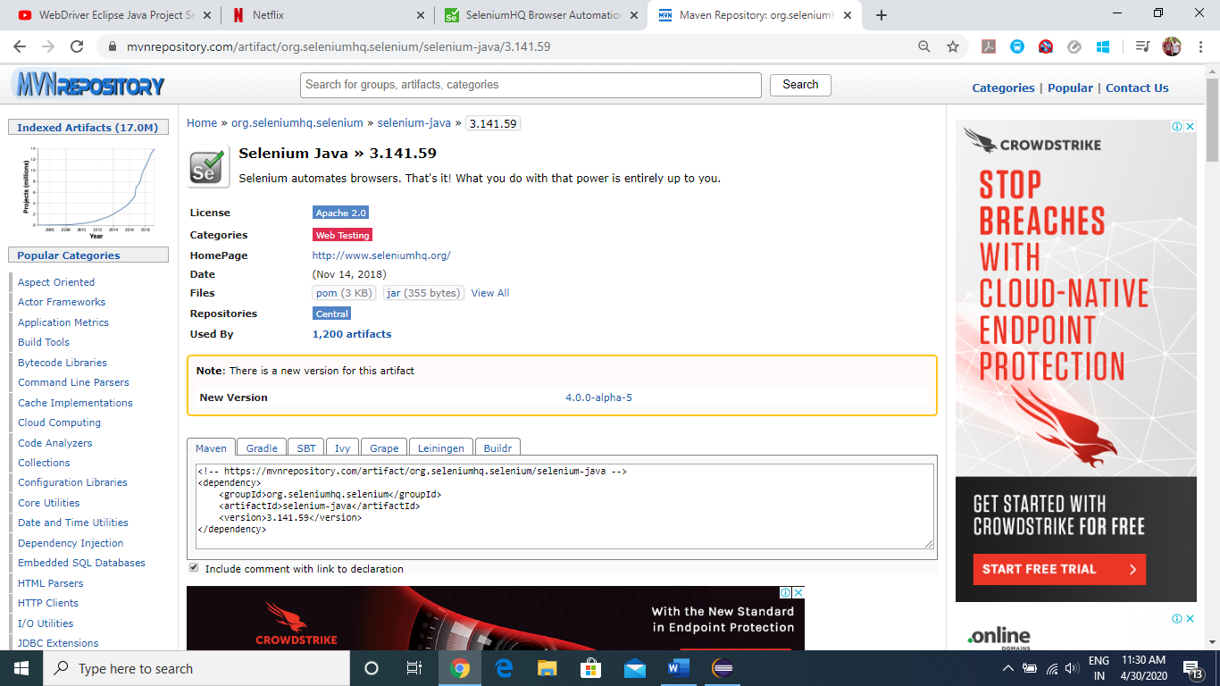

Just Copy the code from Maven tab as show below

<!-- https://mvnrepository.com/artifact/org.seleniumhq.selenium/selenium-java -->

<dependency>

<groupId>org.seleniumhq.selenium</groupId>

<artifactId>selenium-java</artifactId>

<version>3.141.59</version>

</dependency>

Now we will go back to our Sample project in Eclipse and open POM.xml file

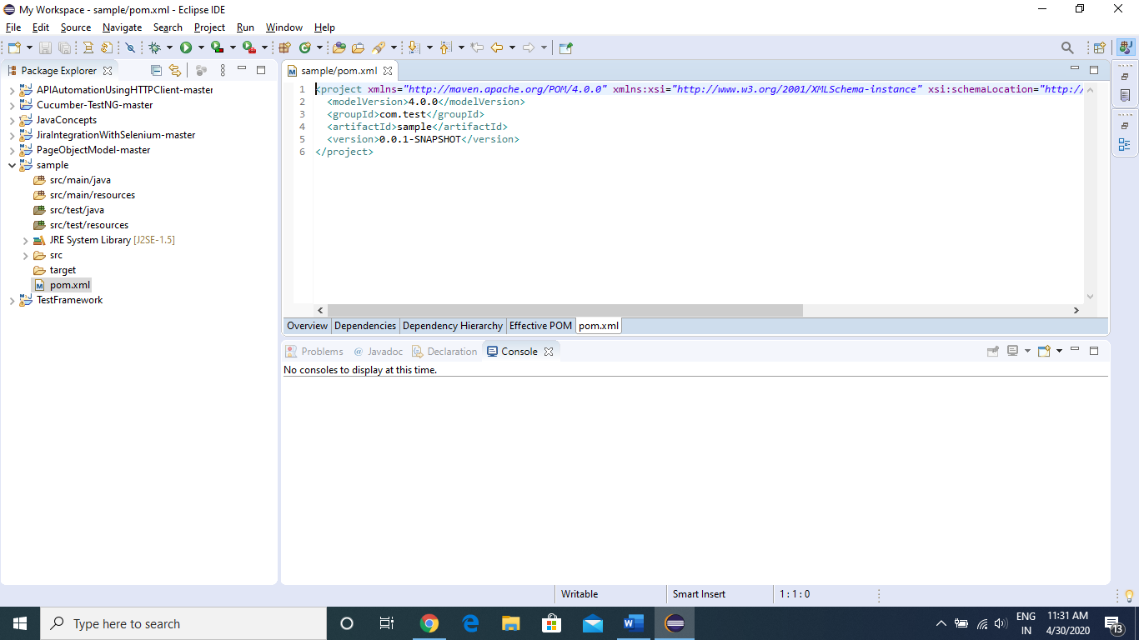

Now paste the dependency here inside <dependencies></dependencies> tag and save it (ctrl +s)

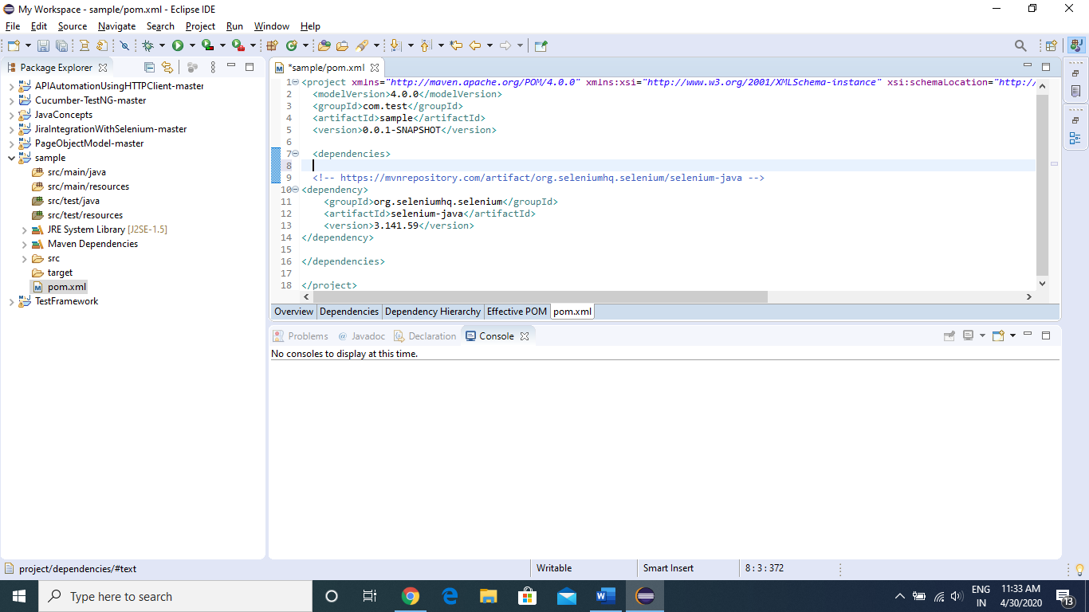

Now we will see, in the Project Explorer panel, “Maven Dependencies” have been created and inside it, all the required selenium jar files are imported.

Now we are ready to test some webpage

To do so, we will be creating a Java class inside **src/test/java** folder. To do that, right click on the folder and follow below shown steps.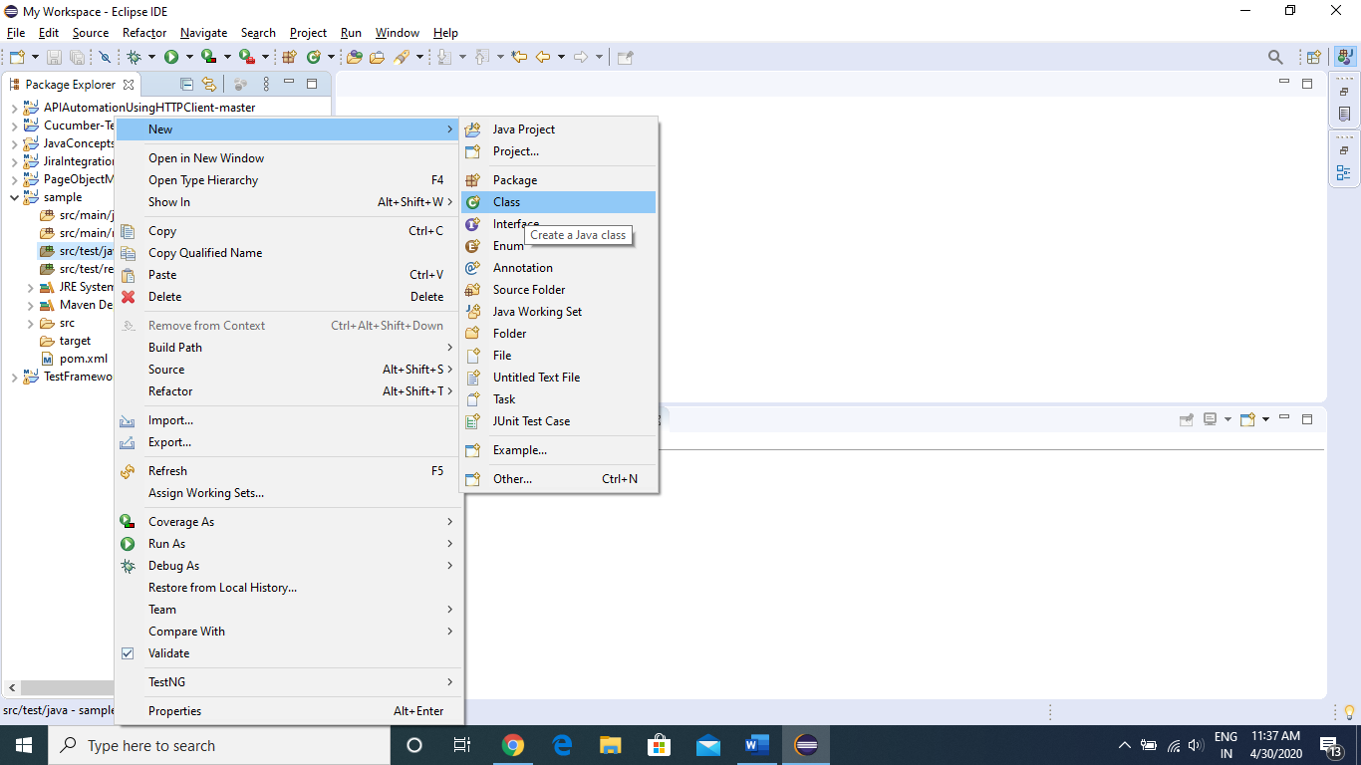

Now here we will have to enter our Class Name. For instance, her I have given the class name as “**LaunchBrowser**”, and click “FINISH”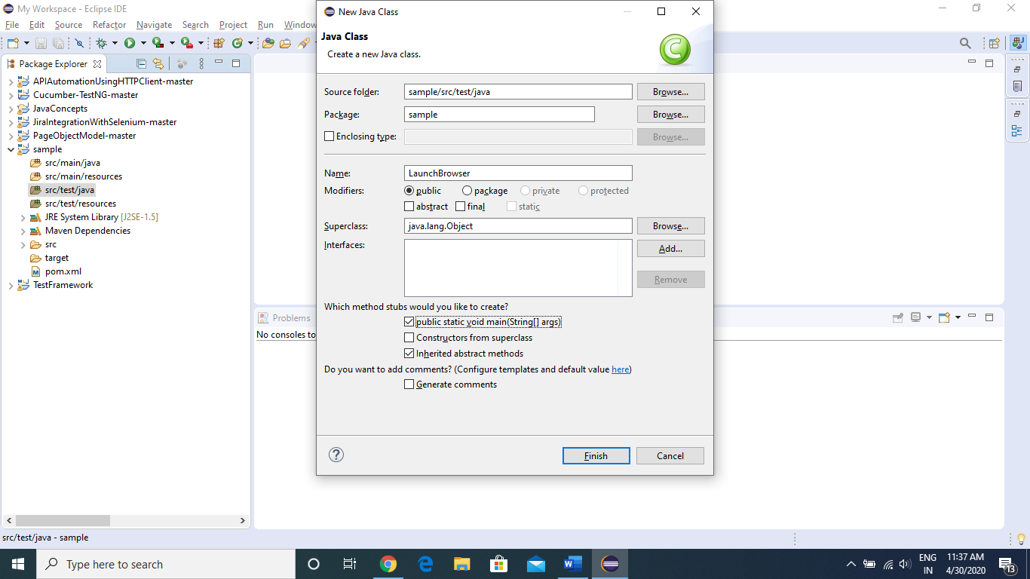

Once Java Class file is created, we will be able to see that class file in Package Explorer window present in the left side. Now go ahead and double click on the class file to open the editor where we will write Java code.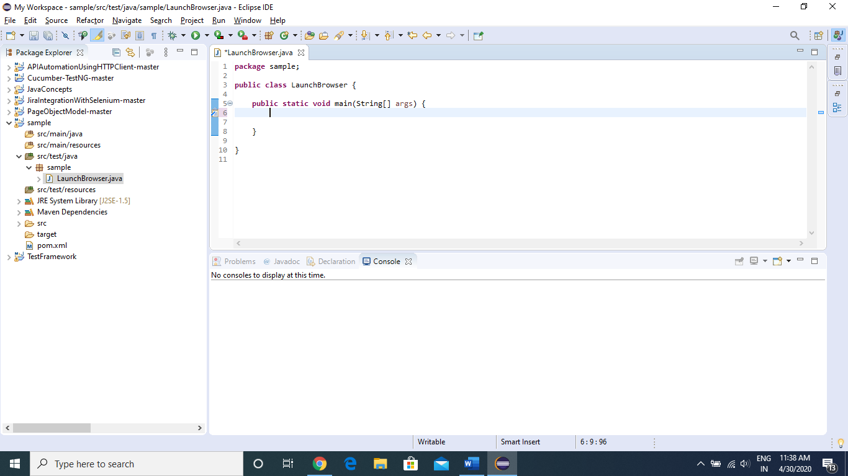

Now as we are going to work with Chrome browser, we will be downloading chrome driver executable file from “<https://chromedriver.chromium.org/downloads>”

**NOTE**: Please download the driver file according to the chrome version installed in your machine

If we want to use other browser (Firefix, Opera.. etc), the again we have to download respective browser driver.exe file. To do that we will have to search in google with below search parameters.

Firefox – firefox driver, Internet Explorer – Internetexplorer driver

**Now go back to your project in Eclipse and start coding.**

Code to Launch a URL in browser and get the title of page

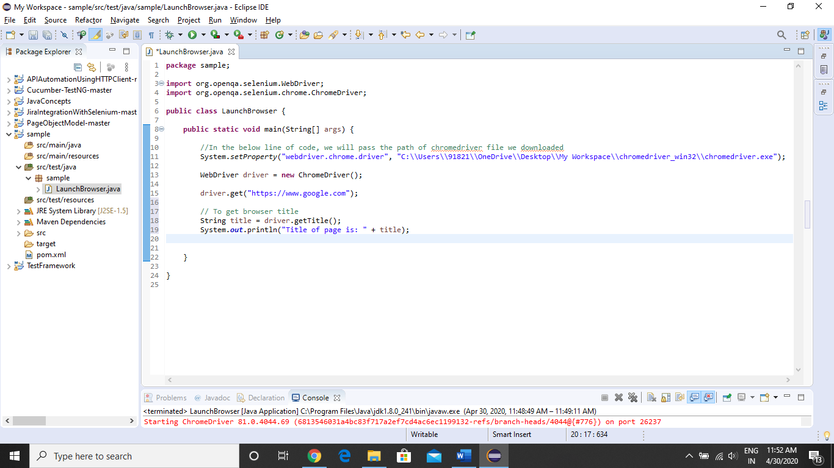

Now execute the above code, by right clicking on the editor window and following the process as shown below

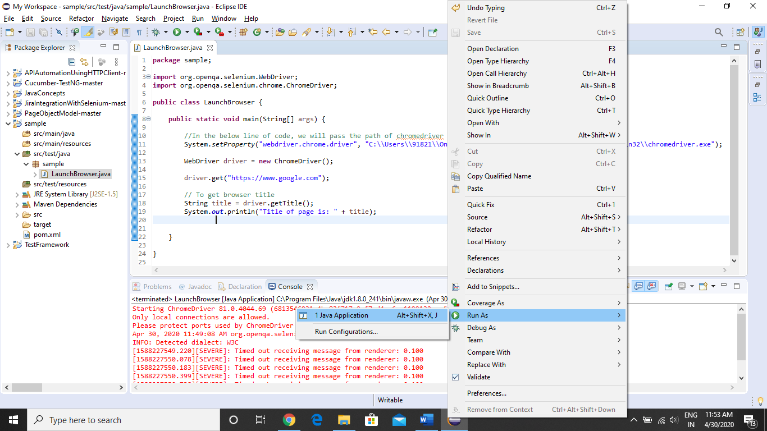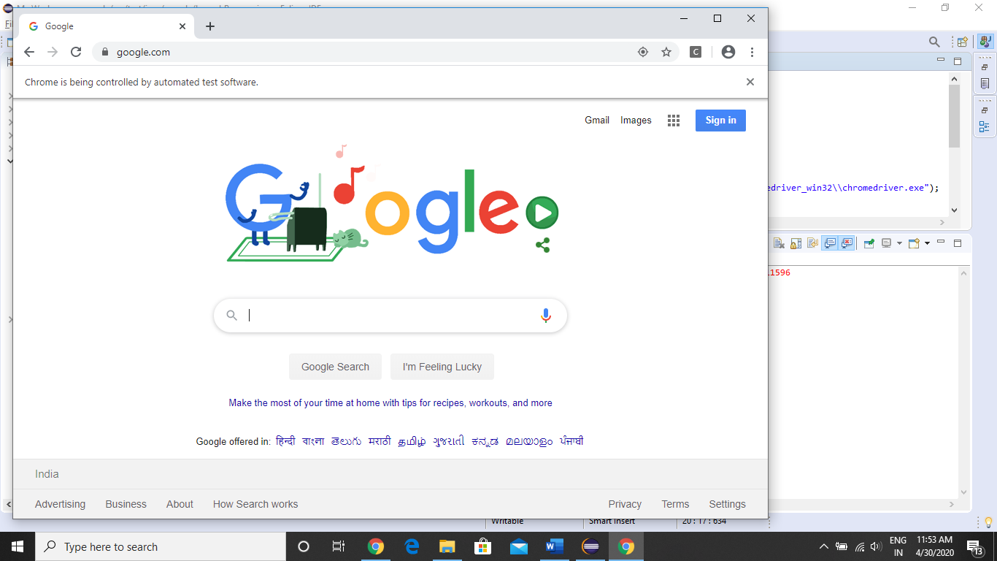

As we can see, in console tab (here will will get the output), we are getting the title of the page

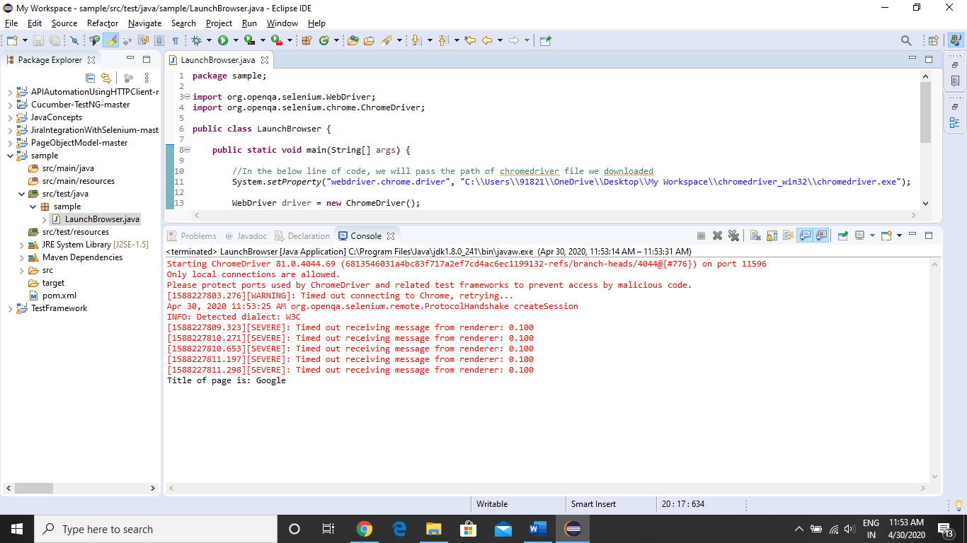

**Now we will see, how to perform actions on Webpage elements**

To perform some actions, we need some property of that element.

Elements can be text fields, dropdowns, radio button, check box, buttons, links, etc.…

To create XPATH or to capture some properties of element we have to use “Inspect Element” feature of google chrome web browser

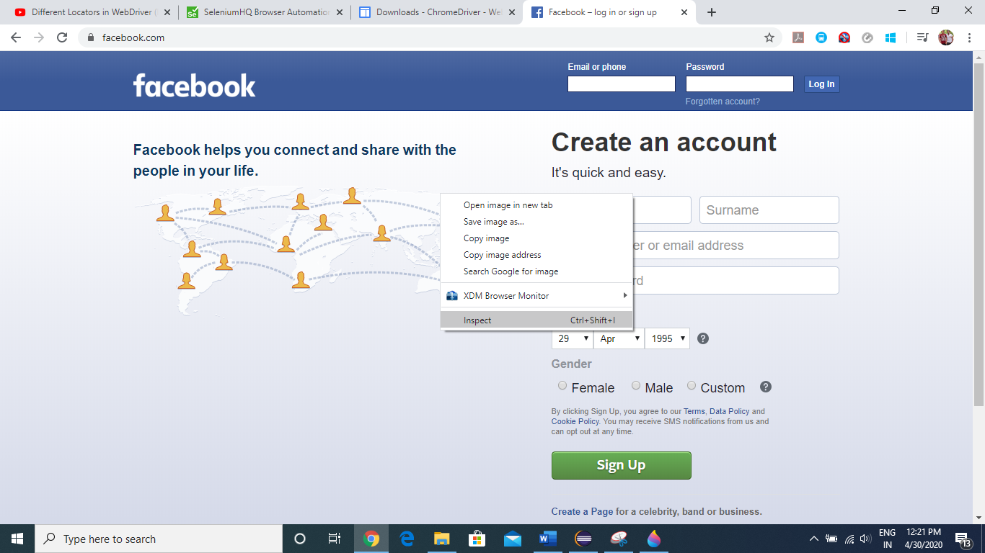

To Select the element in the page to inspect it, click the below button

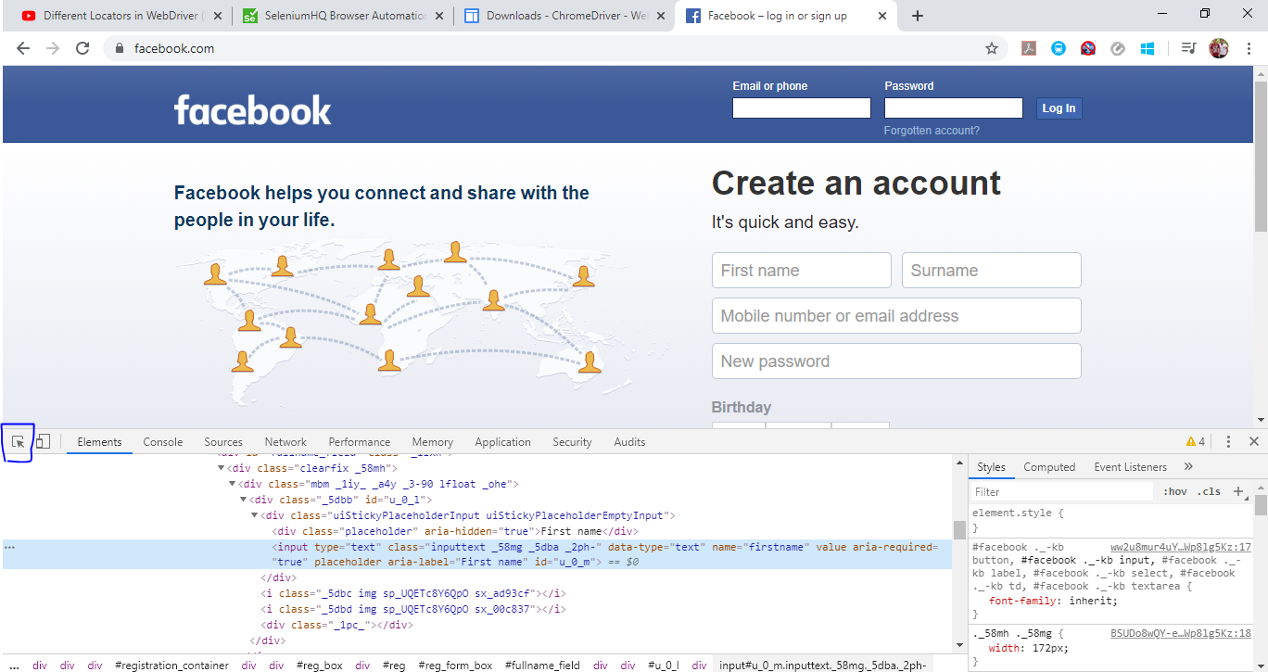

Now click on whatever element you want to inspect, here we are taking “First Name” text box as our element

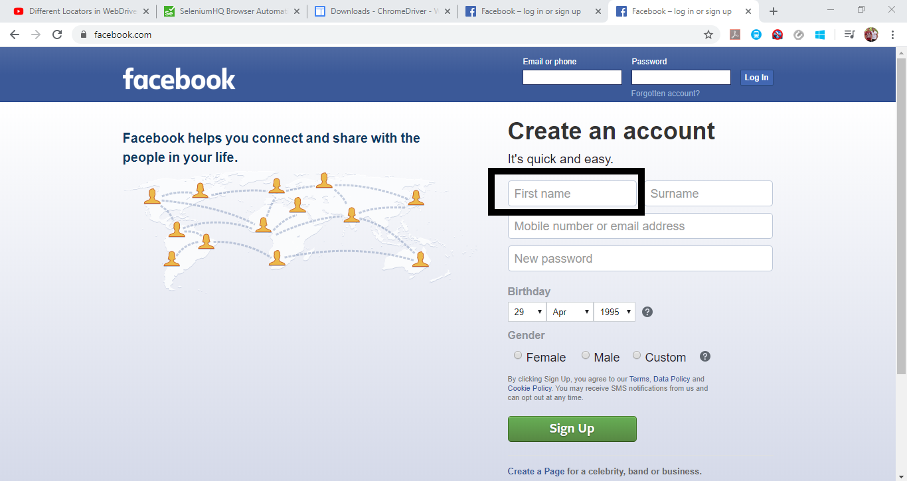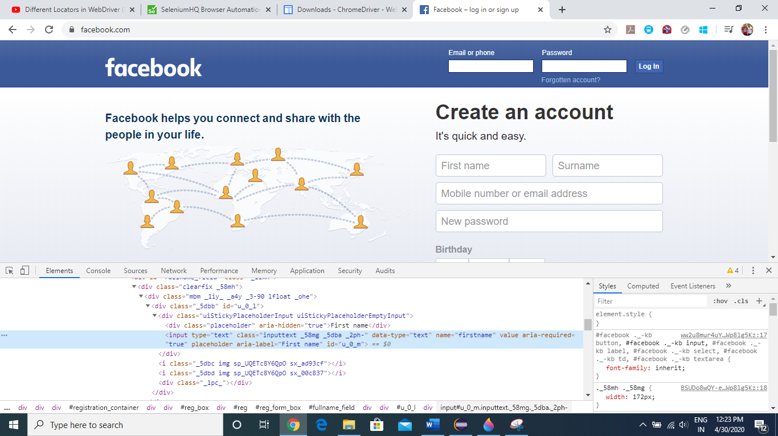

Now as we can see, once we click on the text box, we will get the properties of our test box under elements tab.

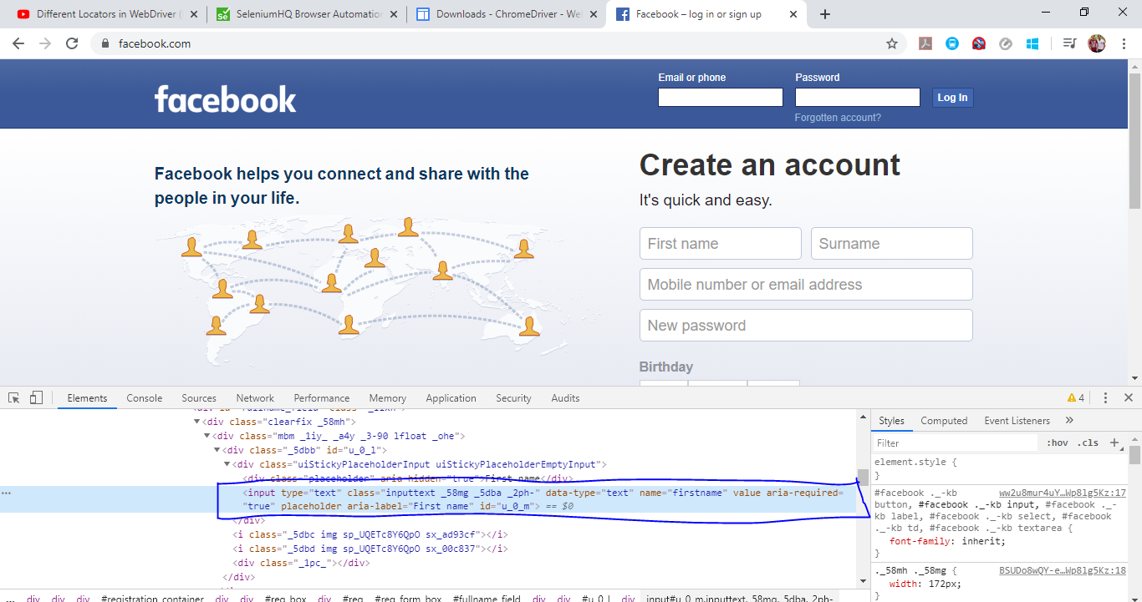

From here we will use whatever property we require to create our locators.

There are total **8 types of locators**, based on the element property we have to determine which locator to use for a particular action. 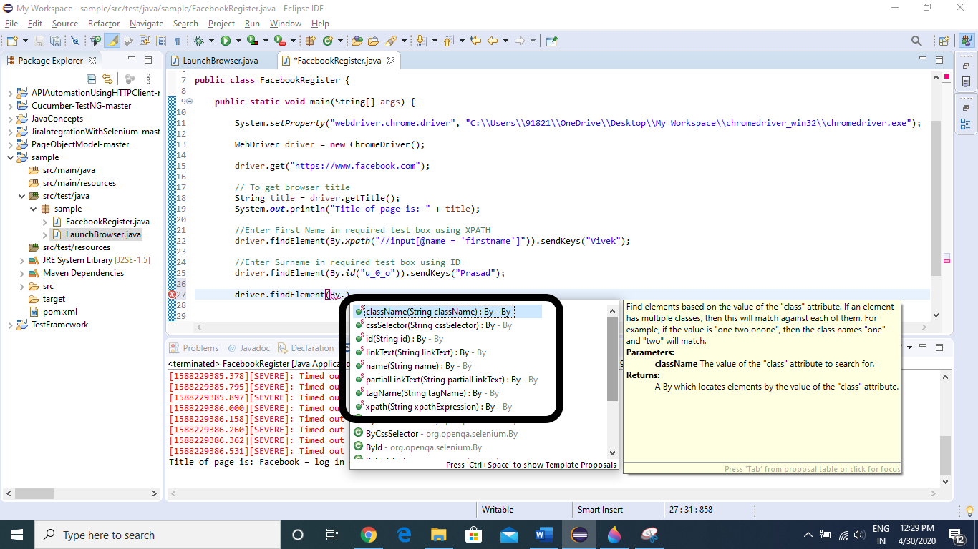

Now we will go to “Facebook.com” and try to enter “First Name” via **XPATH** (Locators)



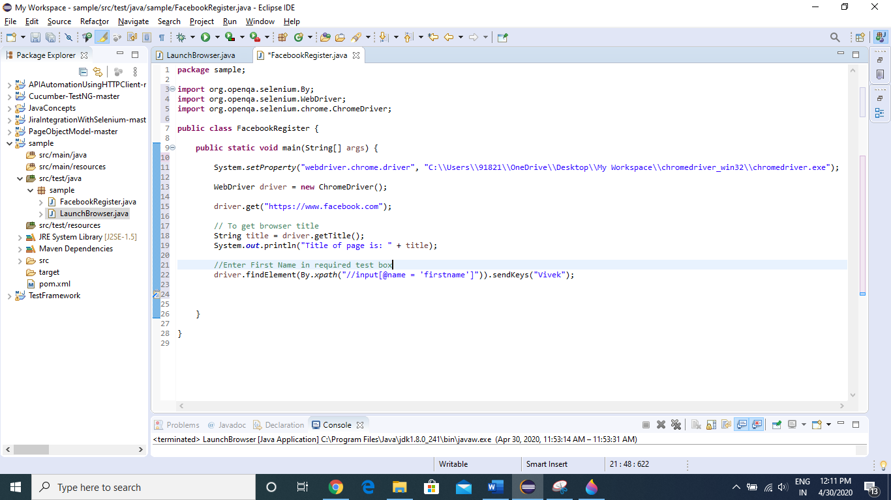

In Console, we can see title of page is printed, and in Webpage, First Name is filled successfully.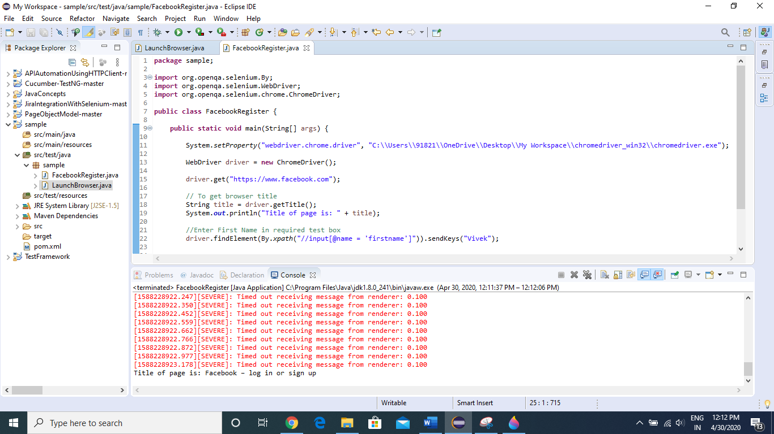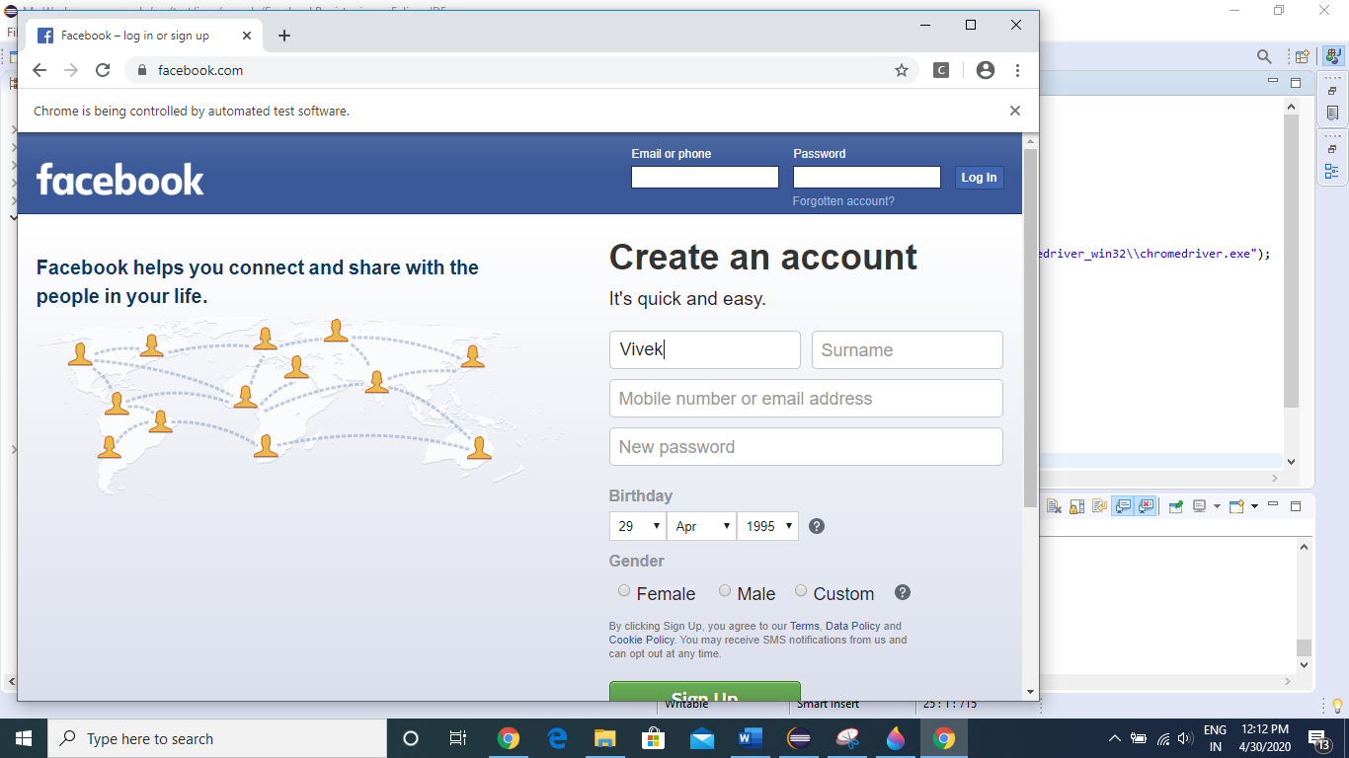

Now we will enter Surname using **ID** (Locators)

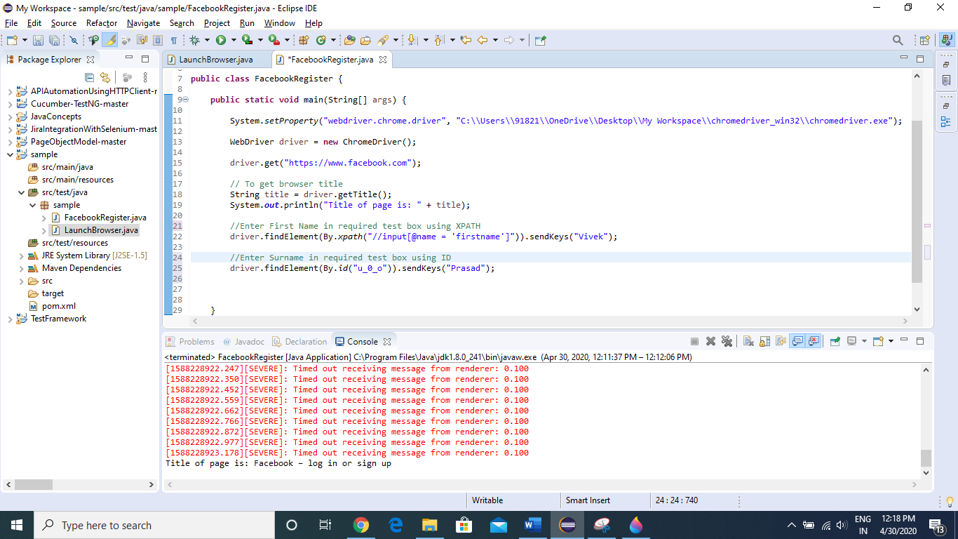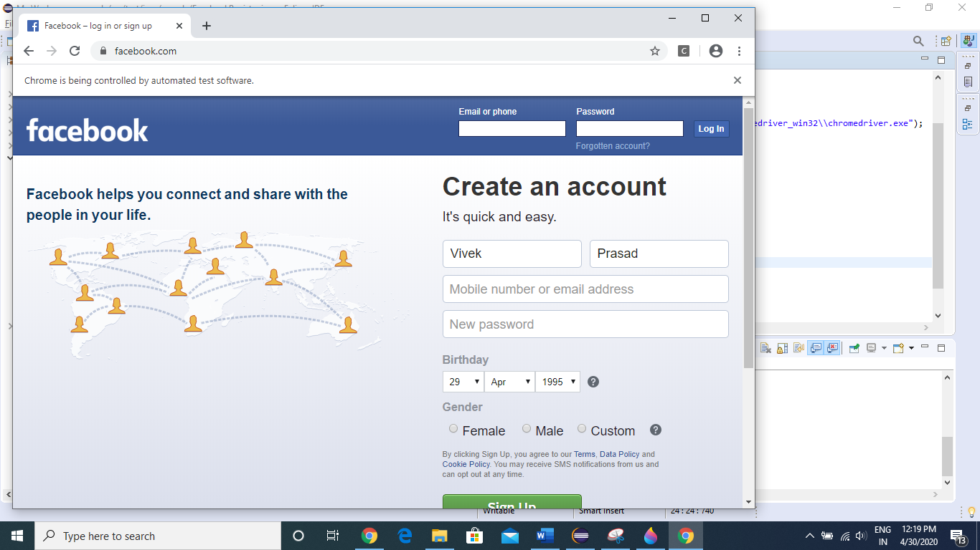

Now we will see how to use different locators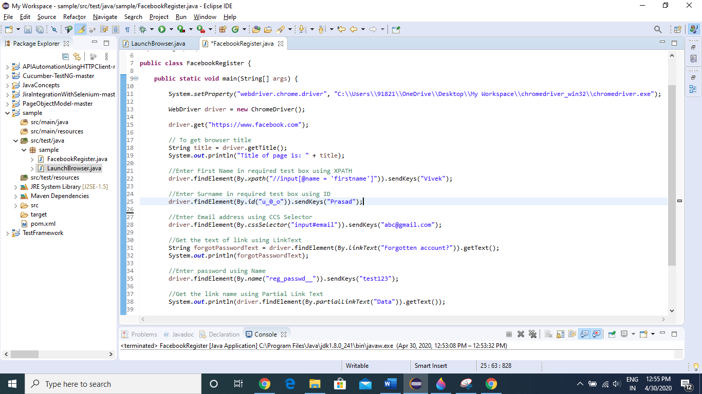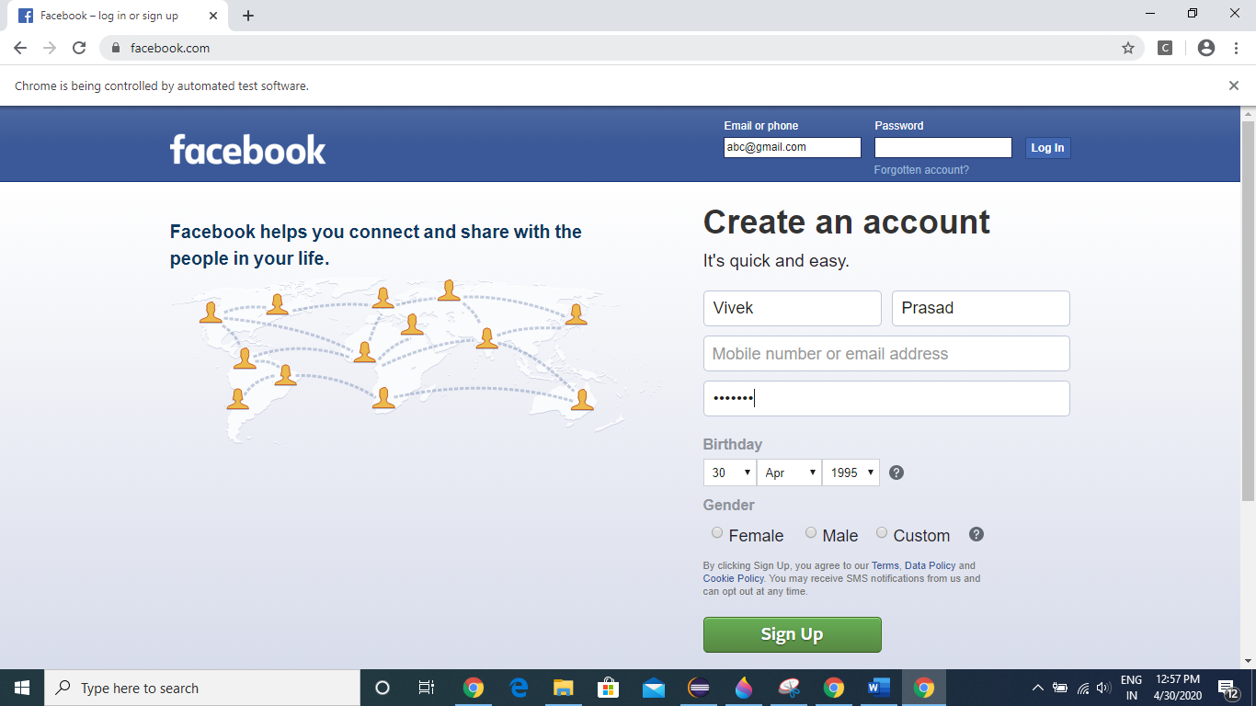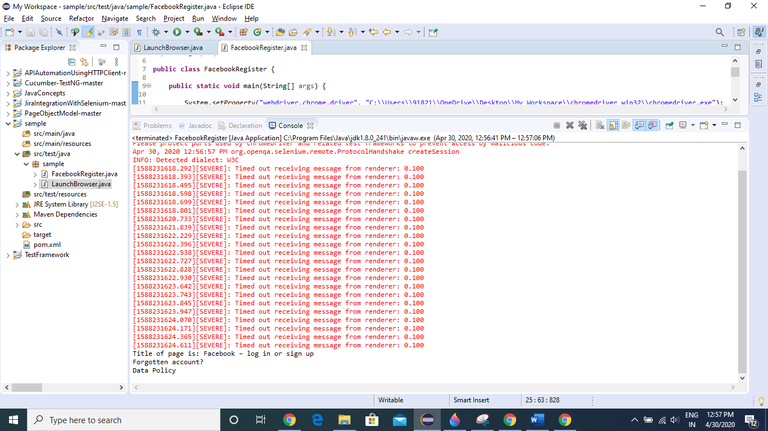

**Now we will see how to handle Dropdowns.**

We can handle dropdowns using SELECT class present in Selenium

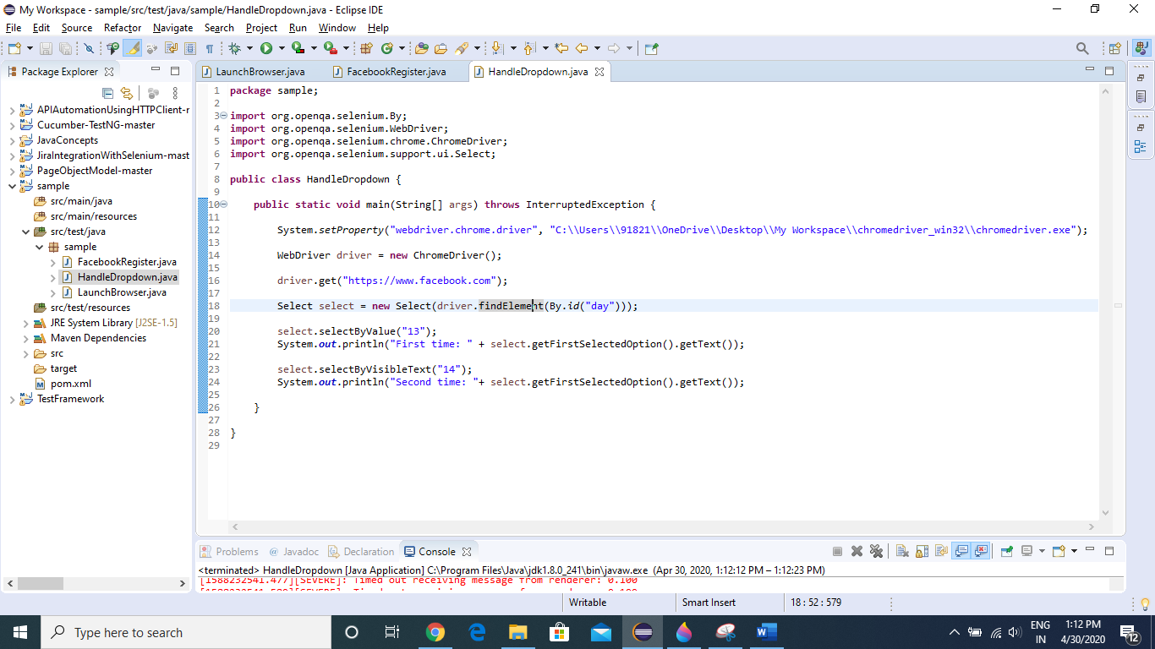

First time it will select 13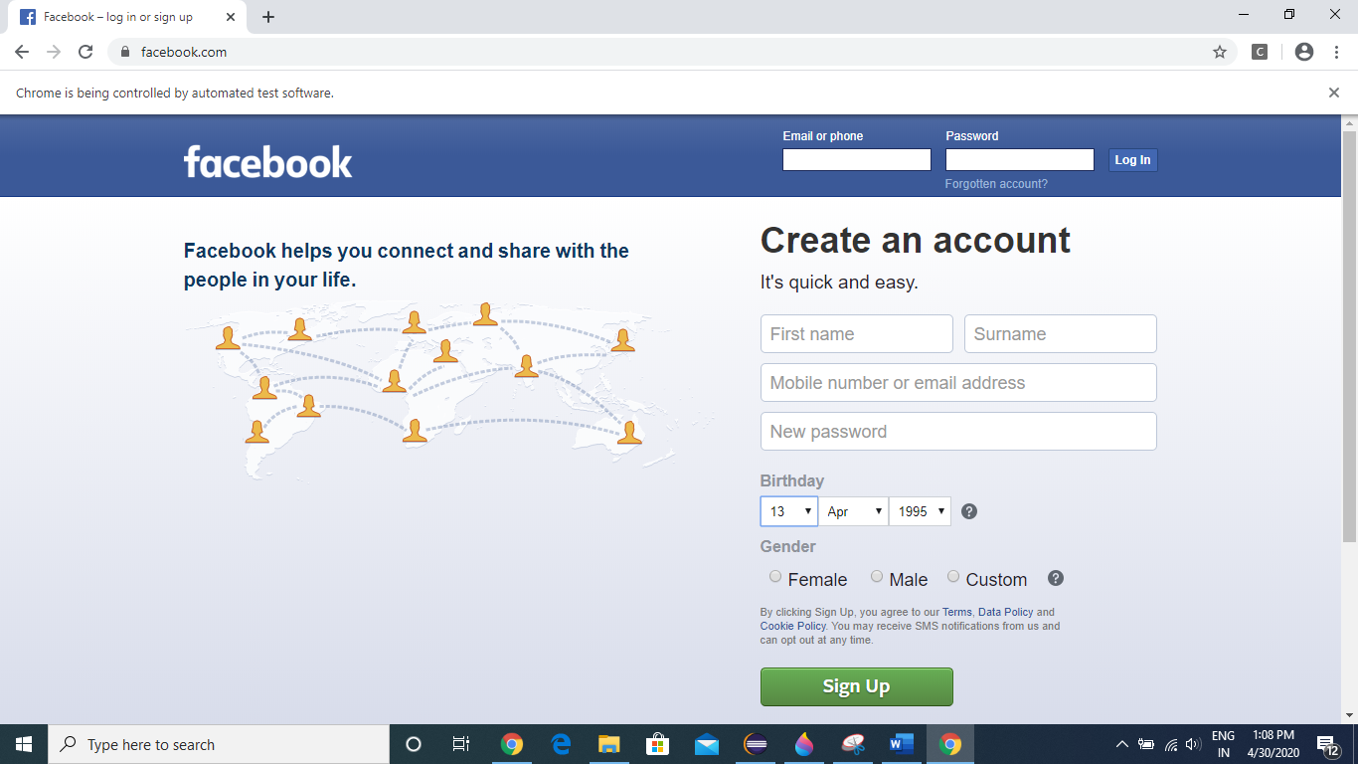

Second time it will select 14 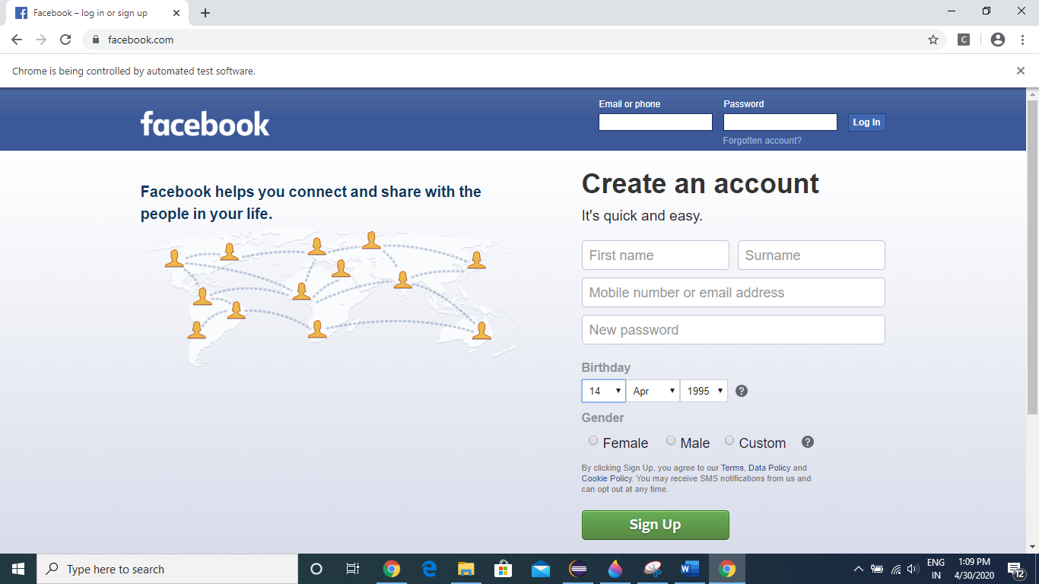

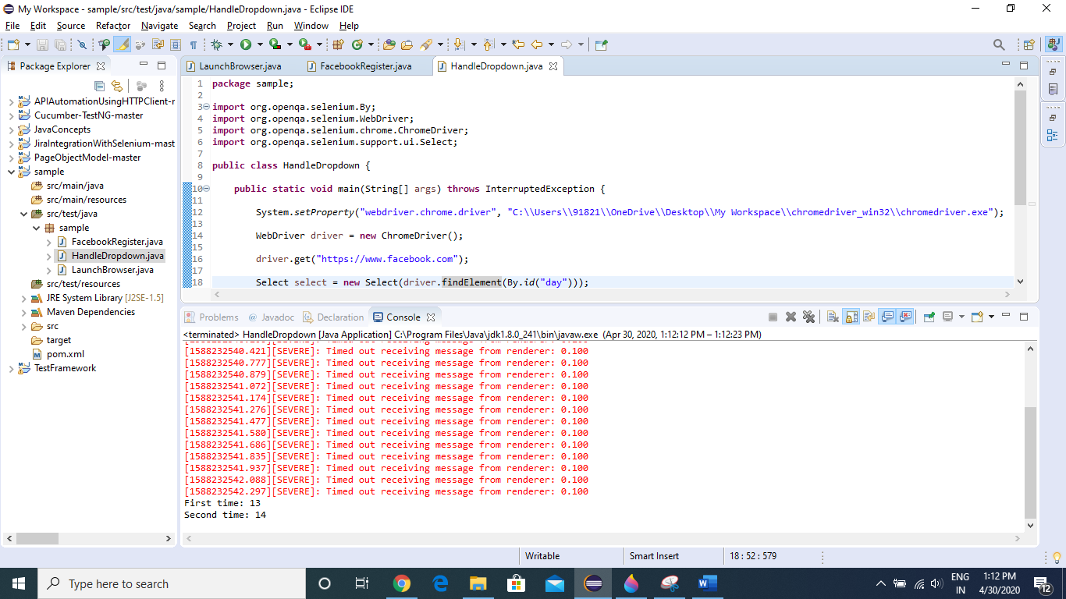

**Now we will see how to handle Radio Buttons/Check Boxes.**

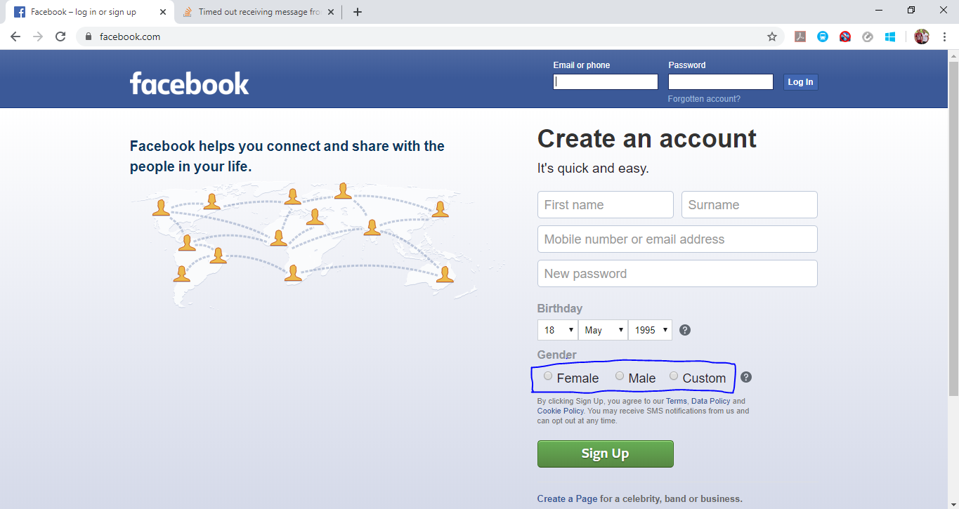

TO click on the radio button we will be using isSelected function of Selenium. If the Radio button is already selected then It will return True else False.

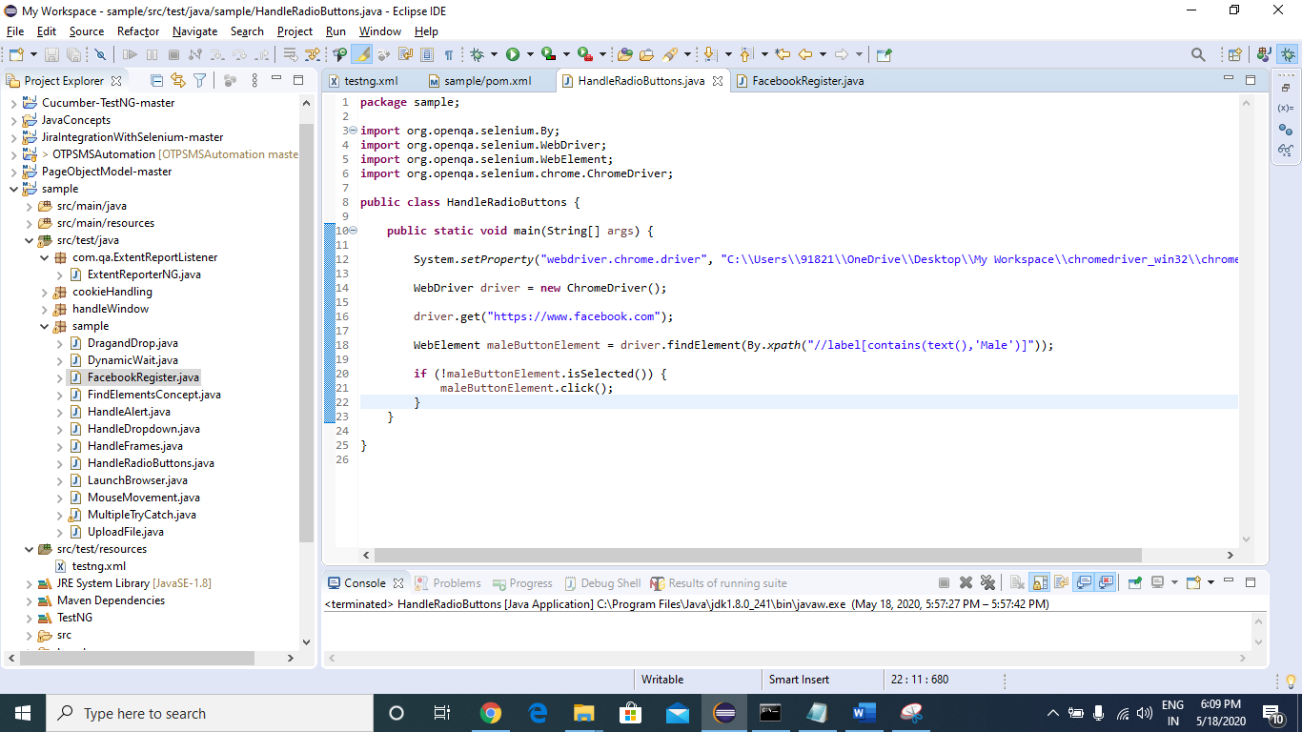

Now we will see how to handle JavaScript Popups /Alerts. We **cannot** inspect this “OK” button.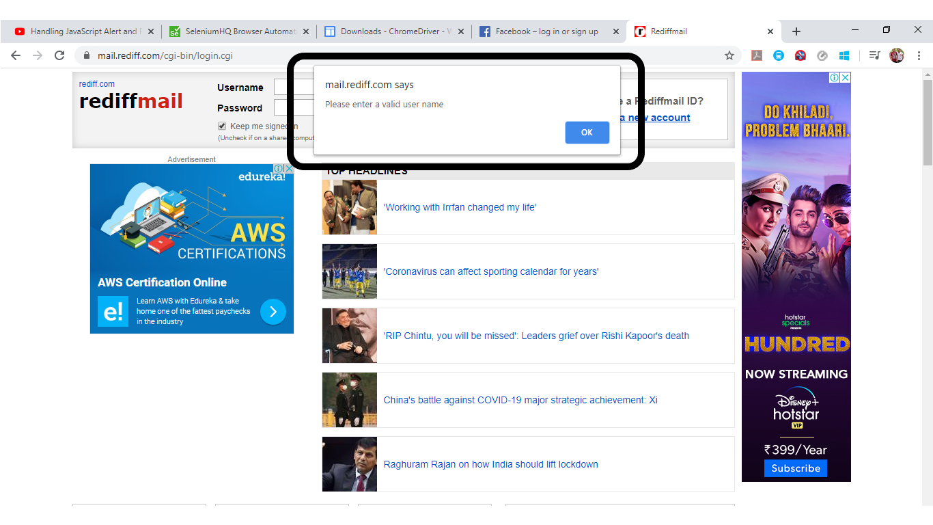

We can handle these Alert box using “Alert” class present in selenium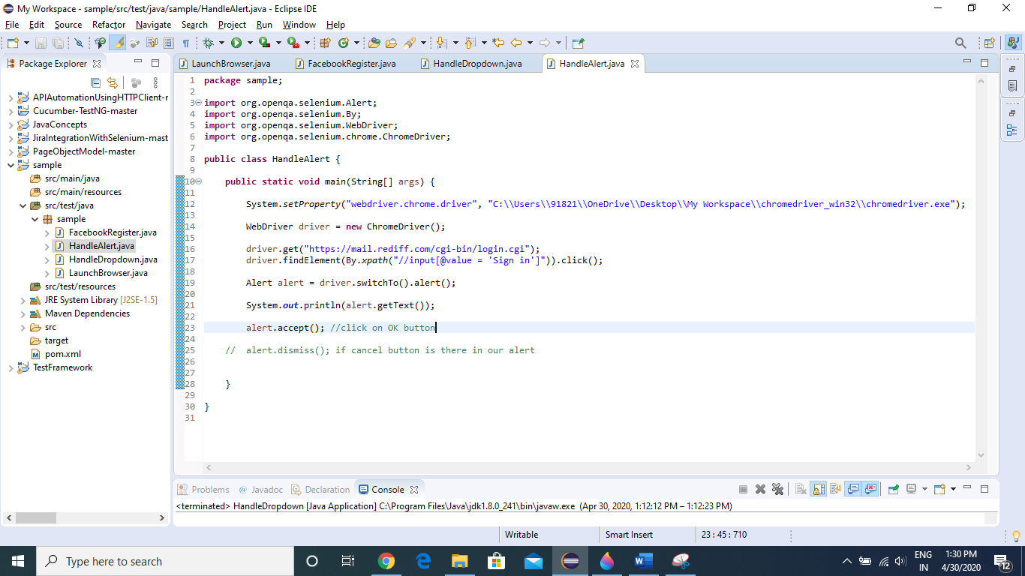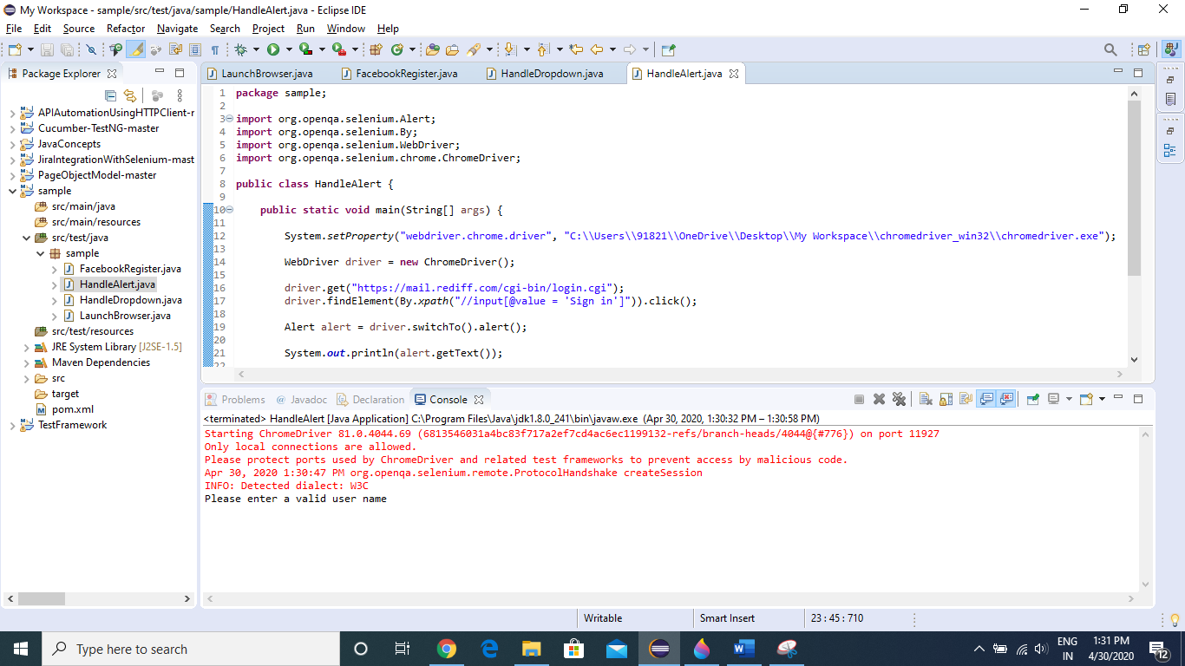

Now we will see how to upload a file in a webpage

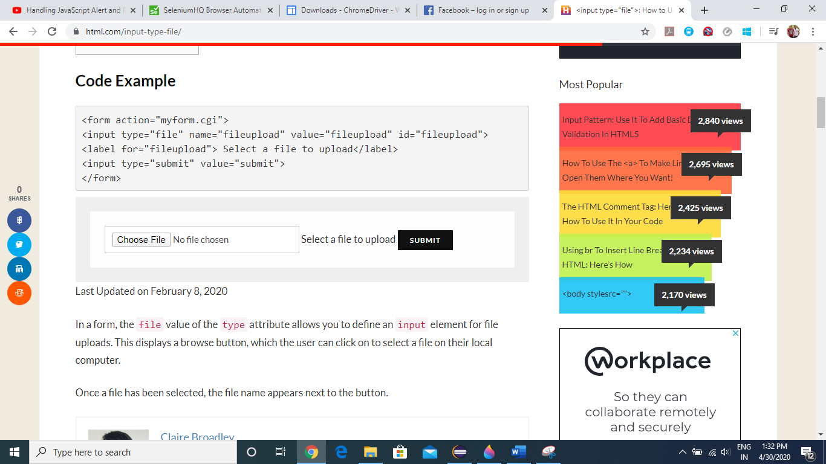

Once we click “Choose File”, a window popup will open and it cannot be handled via selenium

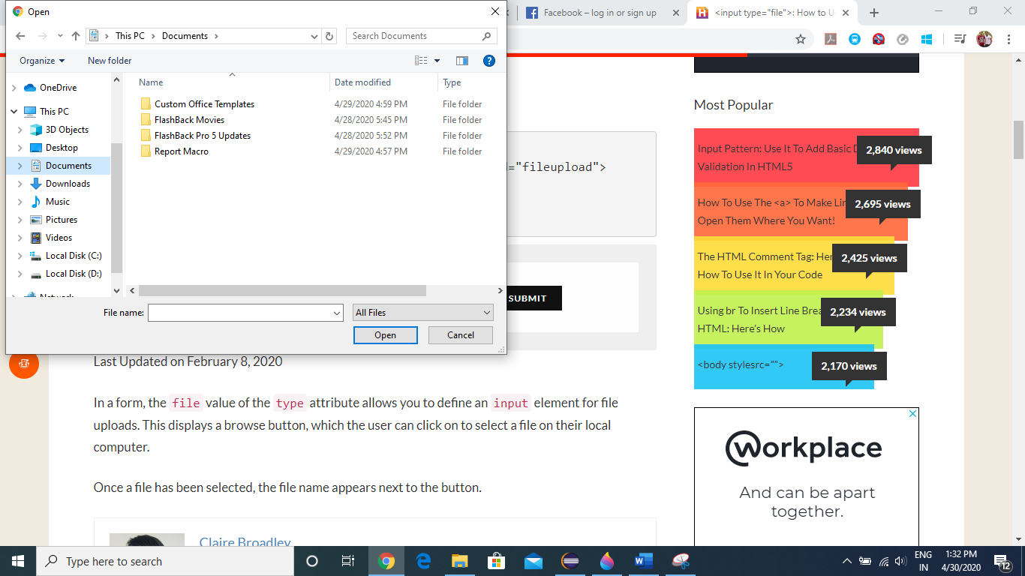

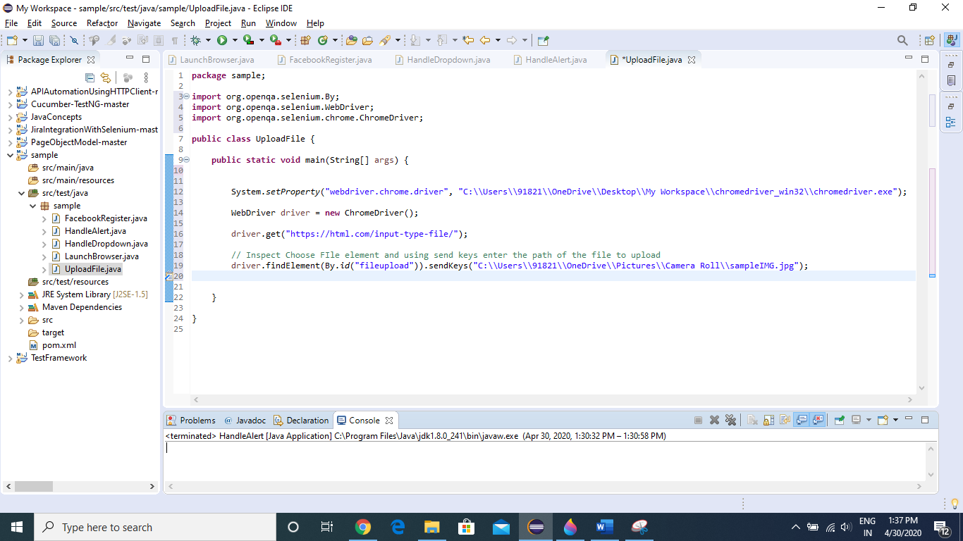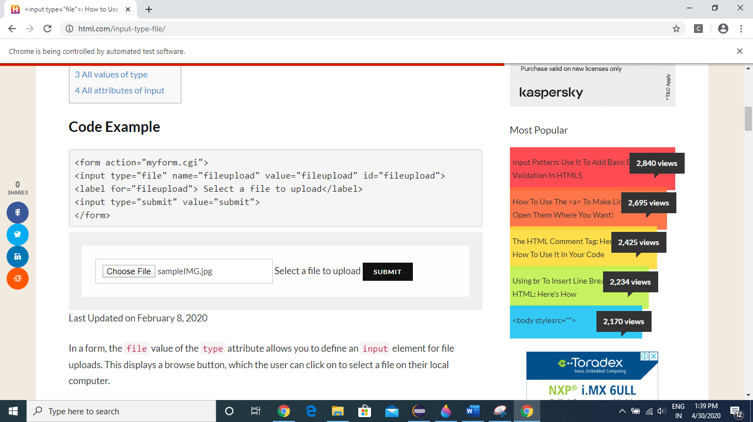

**How to Handle FRAMES in a webpage**

Sometimes we are getting error like element not found exception / unable to locate element, so there can be a reason that the element is present in particular frame.

The below webpage contains iframes.

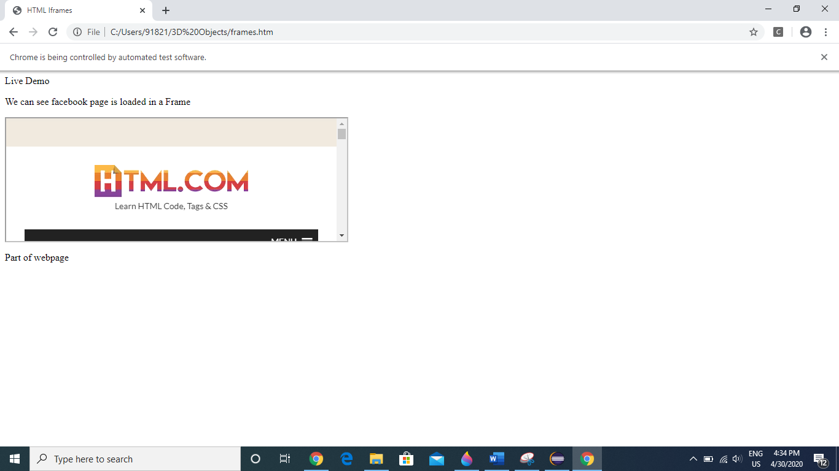 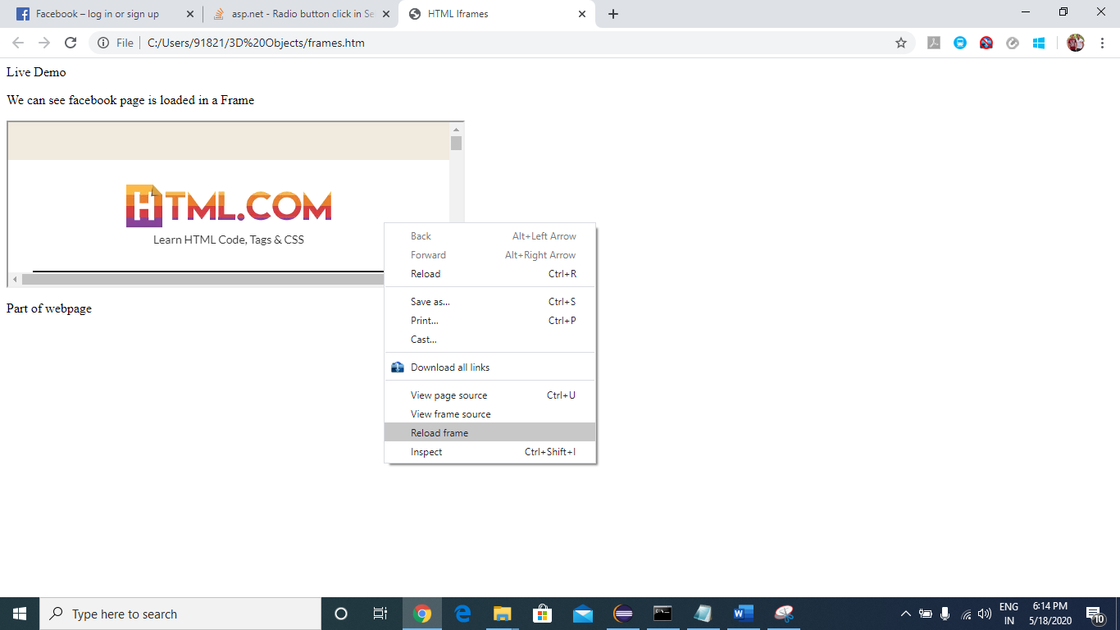

Now we will try to fetch the text “Learn HTML Code, Tags & CSS” directly via XPATH, as a result we will get “No Such Element Exception” because it is present under Frames. Now we will try to access this part using frame handling method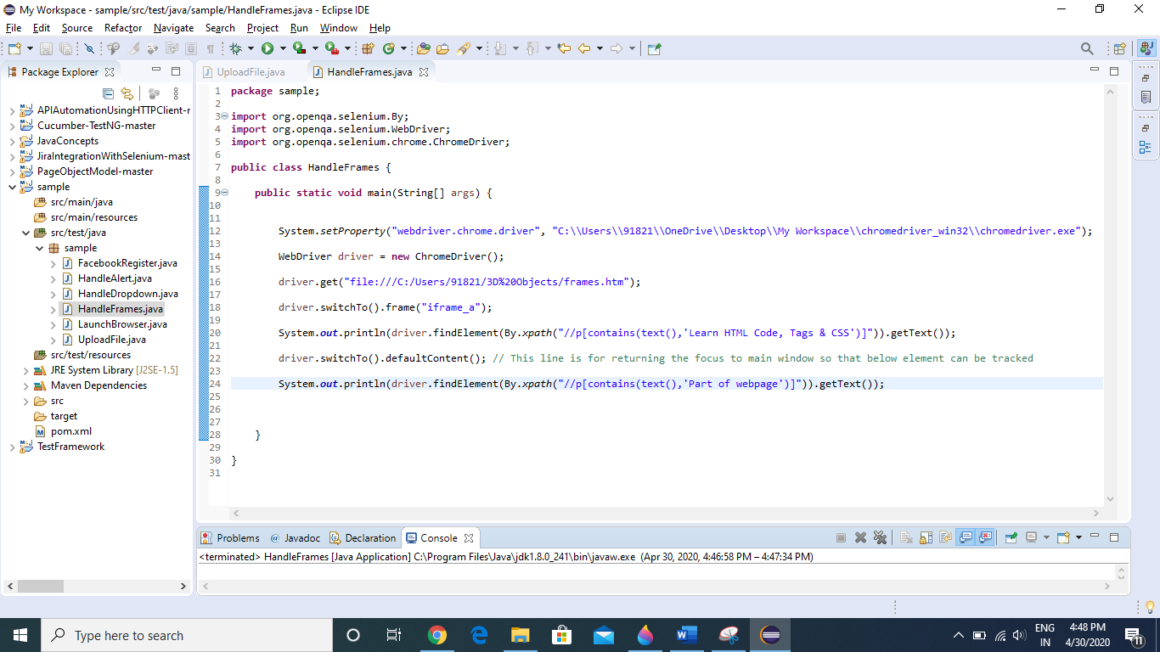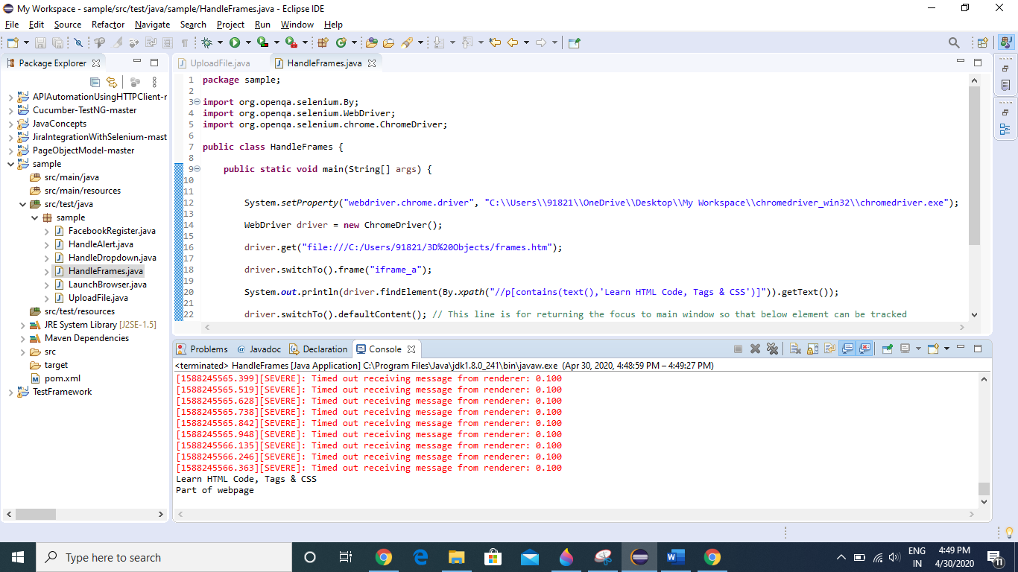

How to Move hover to certain element in a webpage

Once we moreover to “Add Ons” link in menu, we get this sub menu, but as soon as the position of cursor changes the menu closes.

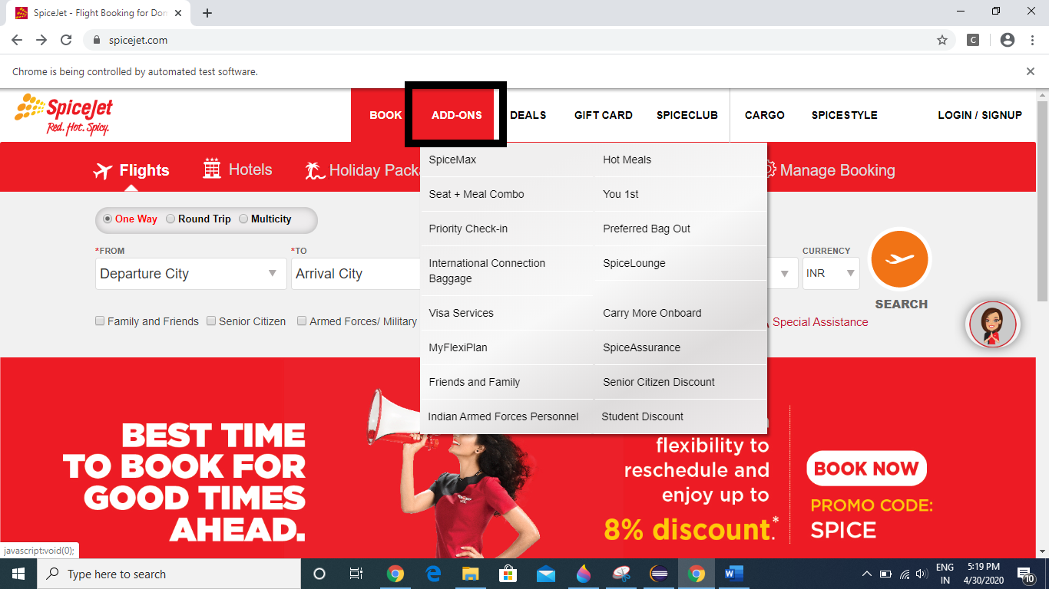

So, lets see how to handle this type of scenario.

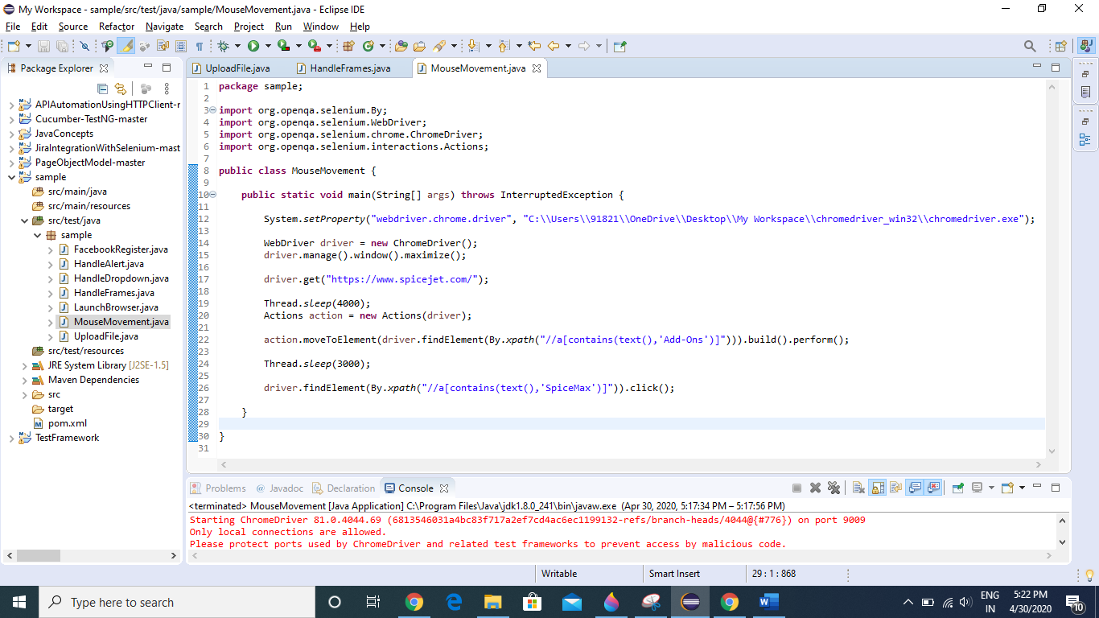

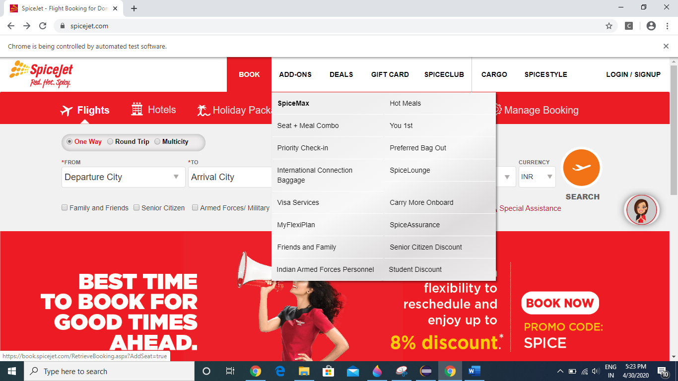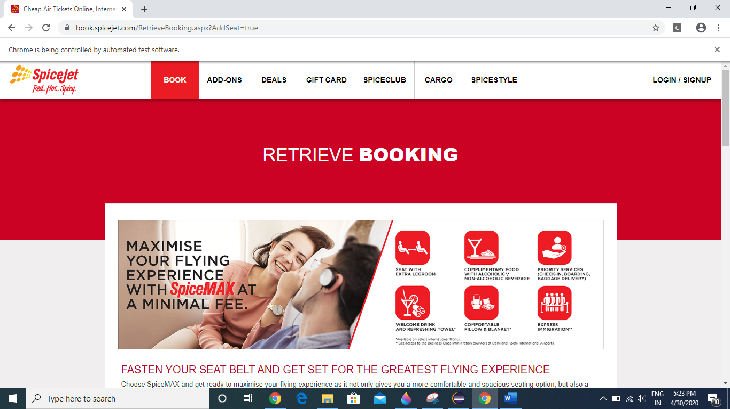

Perform Drag and Drop in webpage

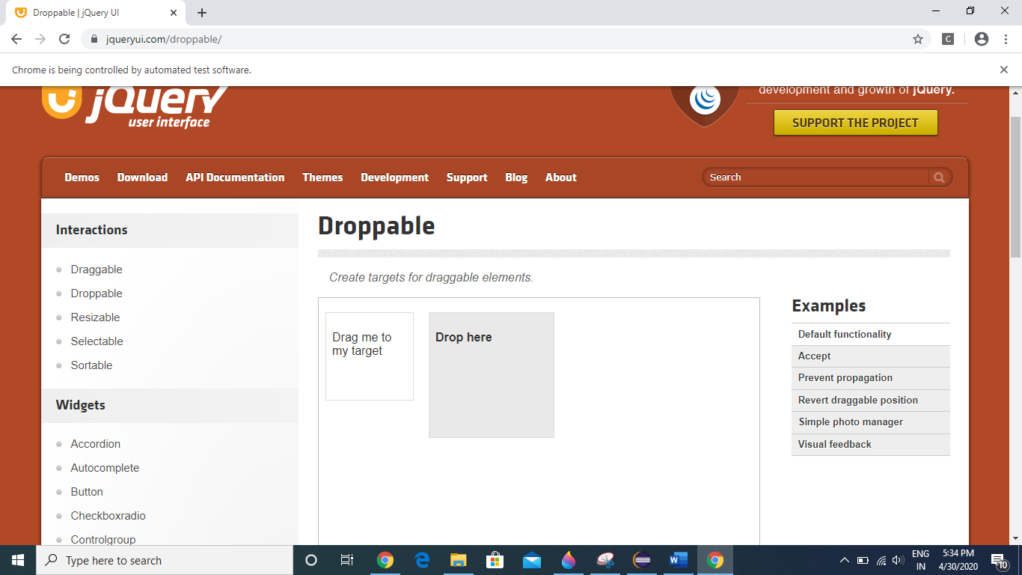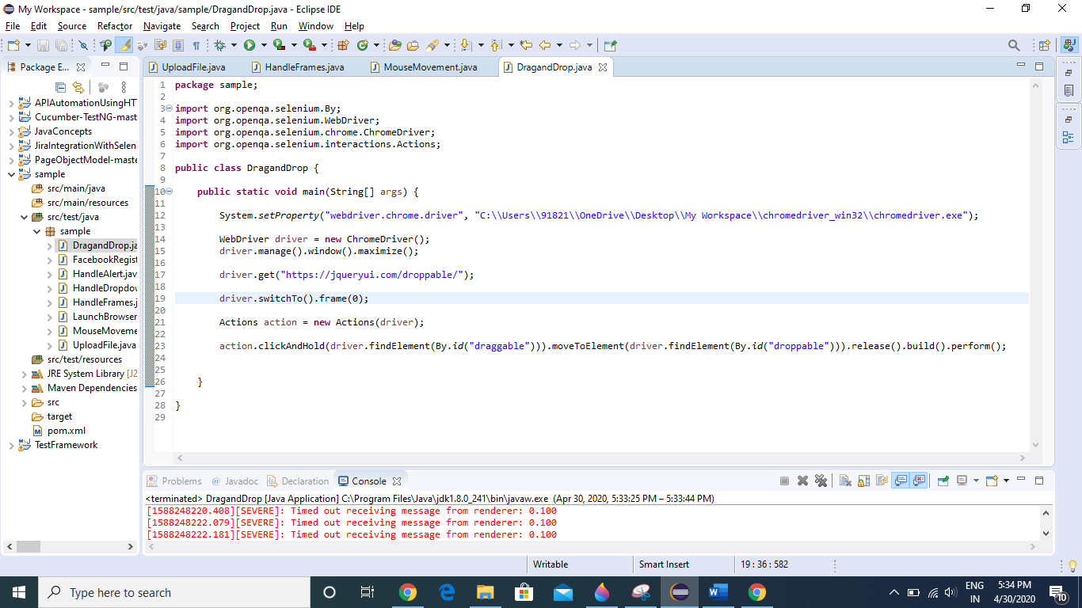

After executing the above code

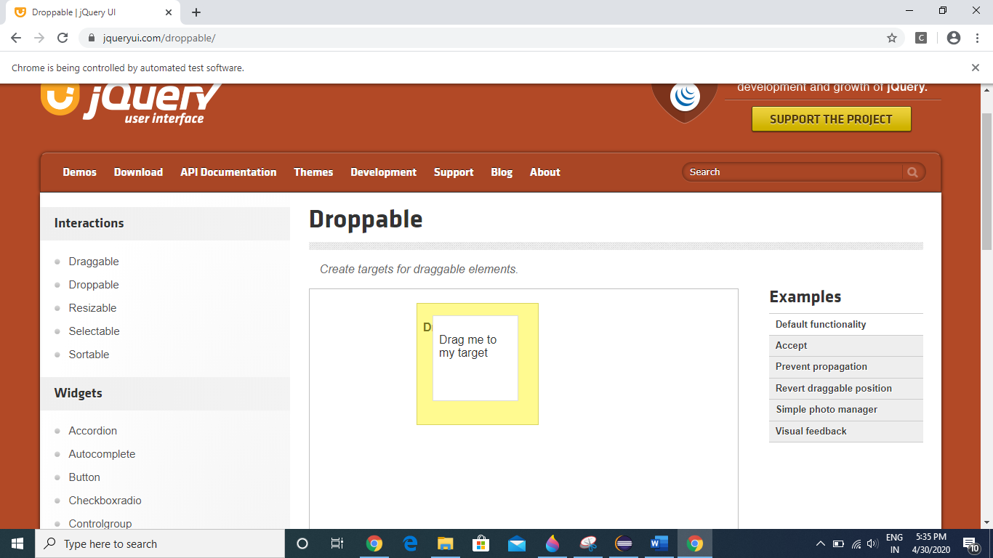

**Dynamic Wait**

* Page Load Timeout , Implicit Wait, Explicit Wait

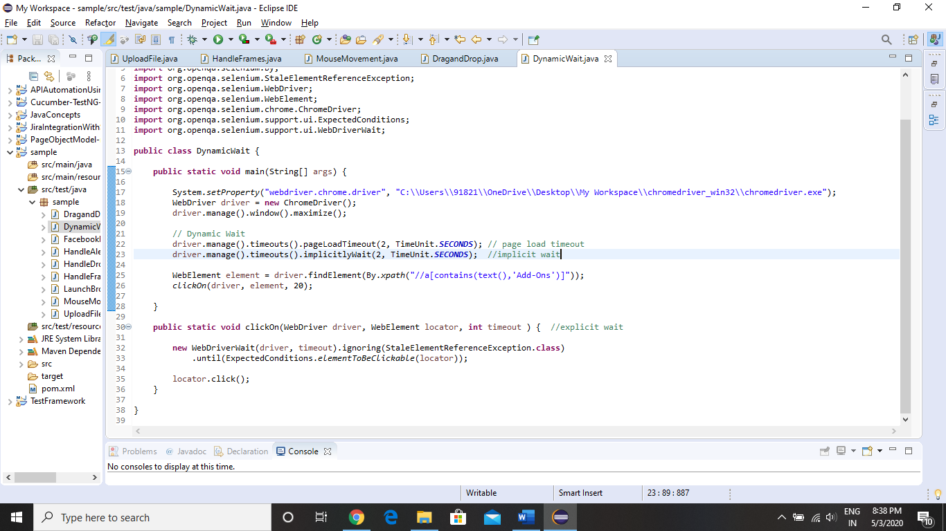

**Find Elements Concept**

Using findElements, we can store all the webelements present in our webpage in a List and then use it as per our requirement.

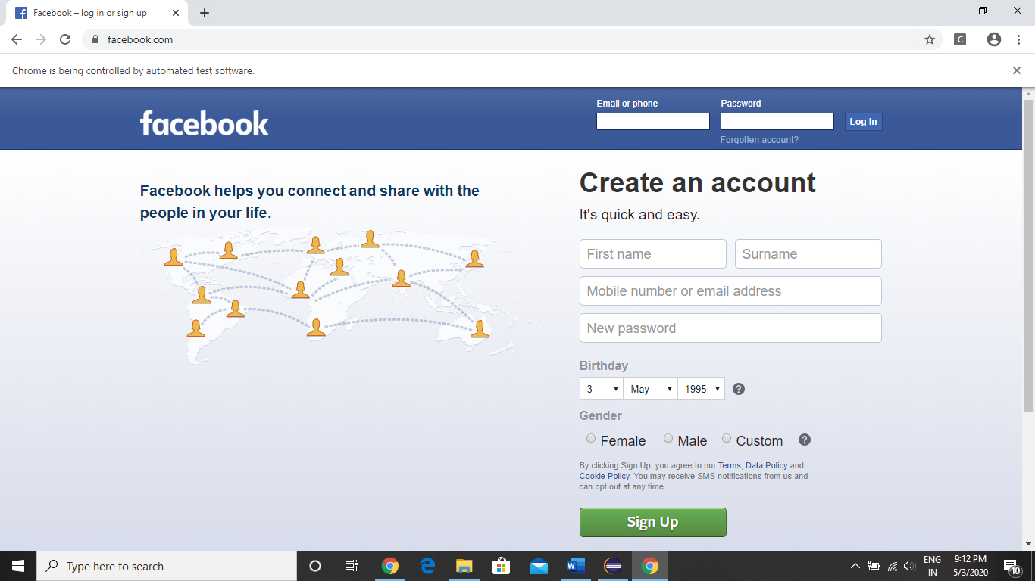

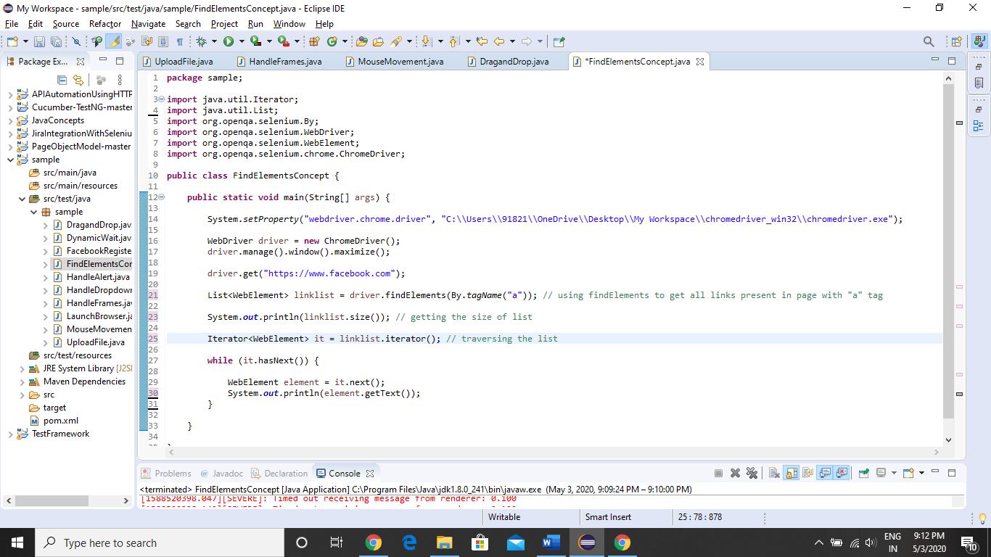

Here first we are getting the size of list (How many number of links with a tag in the webpage)

Then we are printing the name of all the links.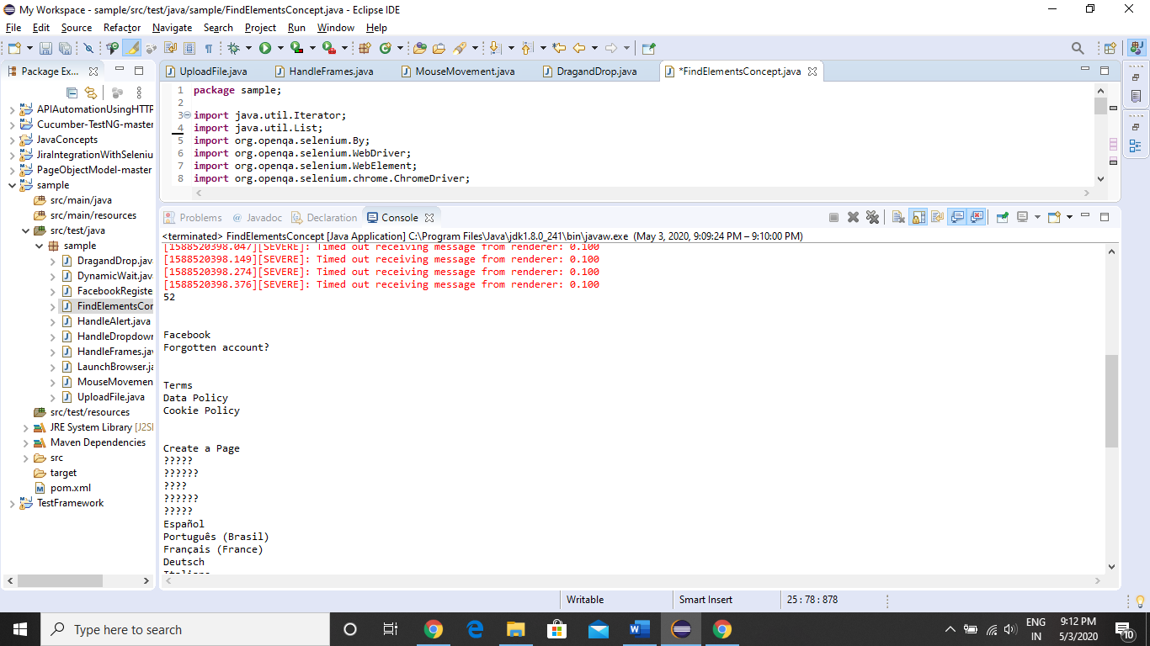

**How to handle multiple windows/tabs/windows popups.**

Here we will see, how we can perform operation on Yahoo, Facebook and Google tab

Here we will be traversing across the Tabs and getting the title of the webpage.

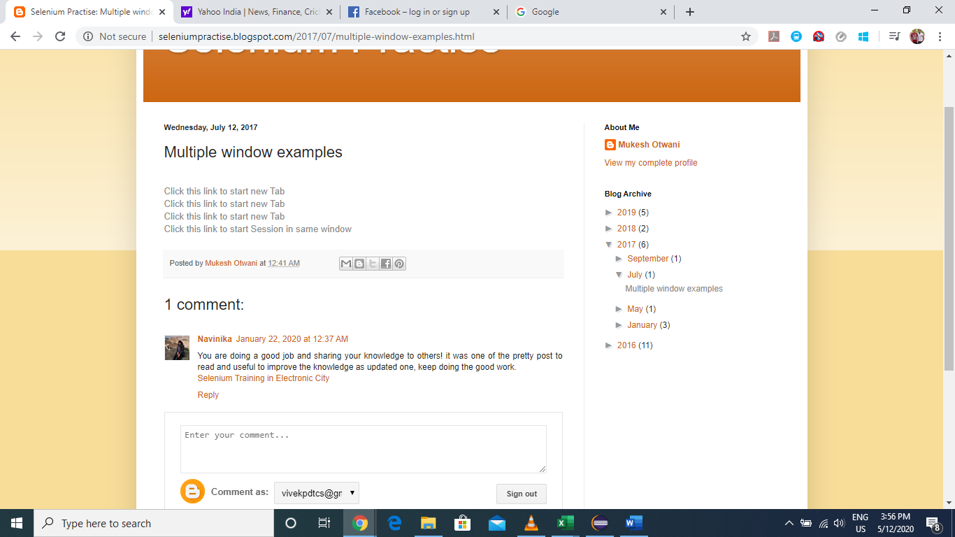

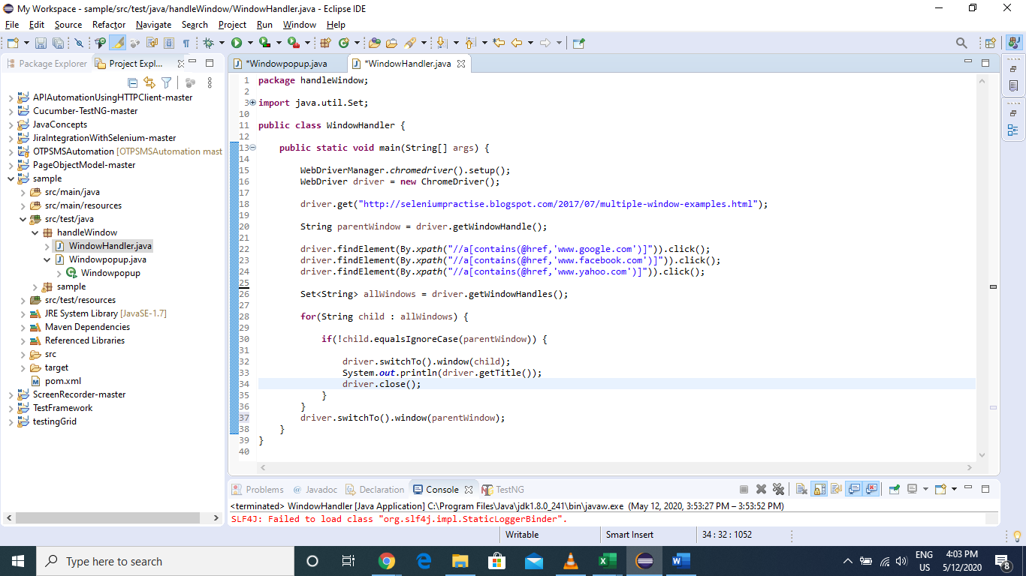

In some webpages, as soon as we open the page, we get **some window popups**.

For example, if we open “Naukri.com”, we will get these 2 windows pop ups as show below

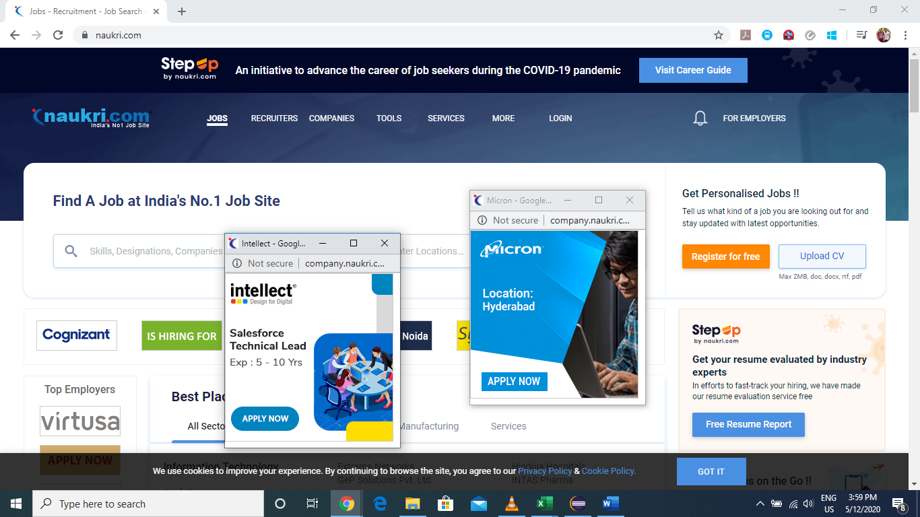

So, lets see how we can handle these window pop ups.

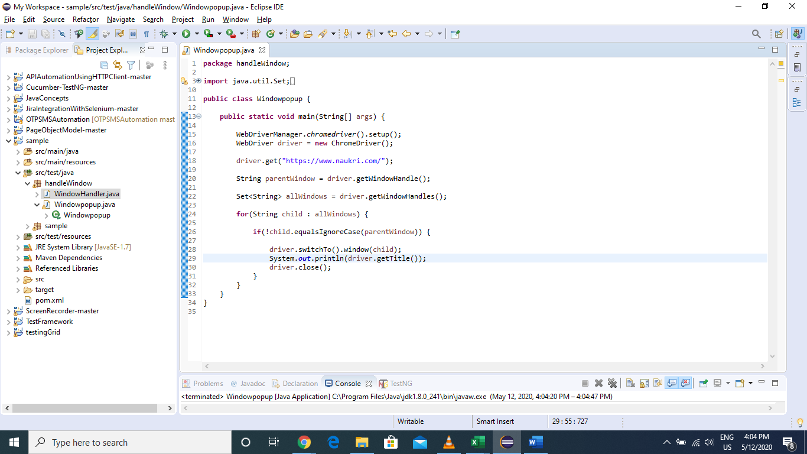

How to Switch to different tabs according to our requirement. Lets say we want to switch to Facebook tab or Google tab or Yahoo tab.

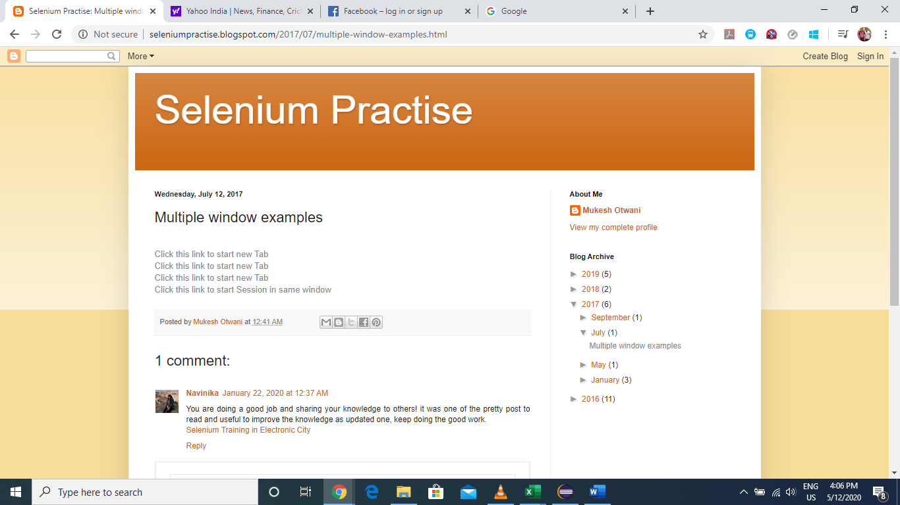

We will be switching tabs based on the page title

